Leveraging AI Generalist in Content Creation and SEO Management in Education Sector

Project Report
Submitted To

Dr. D. Y. Patil Vidyapeeth, Centre For Online Learning, Pune

In Partial Fulfillment of the Requirement for the Award of the Degree of

MASTER OF BUSINESS ADMINISTRATION

BY Amrita Ajay Kumar

ERP ID: 241114817
PRN No.240502006865

Name of the internal Mentor

Vikas Kumar Atray

Dr. D. Y. Patil Vidyapeeth, Centre For Online Learning, Pune.
2024-2026

Declaration

I, the undersigned, hereby declare that the Project Report entitled
“Leveraging AI Generalist in Content Creation and SEO Management in Education Sector”
, submitted by me to Dr. D. Y. Patil Vidyapeeth, Centre for Online Learning, Pimpri, Pune, in partial fulfillment of the requirements for the award of the degree of
Master of Business Administration (MBA), is my original work.
The conclusions and findings presented in this report are based on the information and resources collected from reliable sources and compiled by me. This work has not been submitted to any other University or Institution for the award of any degree, diploma, or fellowship.

Place: Pune

[Amrita Ajay Kumar]


[12/05/2026]

CERTIFICATE

This is to certify that the Project Report entitled “Leveraging AI Generalist in Content Creation and SEO Management in Education Sector”, which is being submitted herewith for the award of Master of Business Administration (MBA) of Dr. D. Y. Patil Vidyapeeth, Centre for Online Learning, Pimpri, Pune, is the result of the original research work carried out by Ms. [Amrita Ajay Kumar] having [PRN No. 240502006865] under my supervision.
To the best of my knowledge, the Project Report submitted by the student is in accordance with the guidelines prescribed by the Institute and the University.
Internal Mentor [Vikas Kumar Atray]

Director DPU COL [Dr. Safia Farooqui ]

Date: 12/05/2026

Organization Letter Head

CERTIFICATE

This is to certify that Amrita Ajay Kumar has successfully completed an internship/training as part of the academic requirements for the MBA Program (Online) at our organization.
During this period, he/she was found to be sincere, diligent, and hardworking in carrying out the assigned tasks and responsibilities.
We wish him/her continued success in all future endeavours.

Authorized Signatory

[Vikas Kumar Atray] 
Seal/Stamp [12/05/2026]
Note: This certificate is optional if not engaged in internship/training at any organization.

ACKNOWLEDGEMENTS

I take this opportunity as a privilege to express my deep sense of gratitude to Dr.
D. Y. Patil Vidyapeeth, Centre for Online Learning, Pune , for providing me with the platform and resources to pursue my research.
I extend my sincere thanks to Dr. Safia Farooqui , Director, Dr. D. Y. Patil Vidyapeeth, Centre for Online Learning, Pimpri, Pune, for her continual support in fostering active learning and for her constant encouragement to achieve excellence. I also appreciate the dedicated efforts of the academic team, headed by Dr. Rajendra Takale, along with all the mentors, whose guidance and inspiration have greatly contributed to the completion of this research work.
I am deeply indebted to my research supervisor, Vikas Kumar Atray, Dr. D. Y. Patil Vidyapeeth, Centre for Online Learning, Pune. Without his/her invaluable guidance, constant motivation, and insightful suggestions, the completion of this project would not have been possible. I am sincerely grateful for the knowledge and research orientation imparted to me under his/her mentorship.
I also wish to extend my heartfelt thanks to all the teaching and non-teaching staff members of the Centre for Online Learning for their unwavering support and cooperation throughout this journey.
Finally, I am profoundly thankful to my family members, relatives, and friends for their encouragement, understanding, and support, which enabled me to complete this research successfully.

Place: Pune [Amrita Ajay Kumar]
[12/05/2026] 

TABLE OF CONTENTS

Chapter no. | Content | Page no.
 | DECLARATION BY STUDENT
 | ACKNOWLEDGMENT
 | CERTIFICATE BY THE GUIDE
 | CERTIFICATE BY THE ORGANIZATION
 | TABLE OF CONTENTS
 | ABSTRACT
1 | INTRODUCTION | 9
2 | OVERVIEW OF ARTIFICIAL INTELLIGENCE | 12
3 | CONTENT CREATION IN THE EDUCATION SECTOR | 25
4 | SEO MANAGEMENT IN EDUCATION | 33
5 | ROLE OF AI GENERALIST IN CONTENT CREATION | 39
6 | ROLE OF AI GENERALIST IN SEO MANAGEMENT | 47
7 | TOOLS AND TECHNOLOGIES | 54
8 | IMPLEMENTATION STRATEGY | 64
9 | CASE STUDIES AND APPLICATIONS | 66
10 | BENEFITS AND IMPACT ANALYSIS | 67
11 | CHALLENGES AND RISKS | 69
12 | FUTURE TRENDS | 71
13 | CONCLUSION | 75
14 | REFERENCES | 77
15 | APPENDICES | 79

ABSTRACT
“Study On Leveraging AI Generalist in Content Creation and SEO Management in Education Sector”
By

[Amrita Ajay Kumar]
MBA Sem IV [2026]

Project Mentor: [Vikas Kumar Atray]
Specializations: [AI & ML]

Search engine optimization (SEO) and content marketing strategies have recently Gone
through a major change because of the rise of artificial intelligence. This research looks
at different ways AI is used in Creating content and how it affects website rankings,
traffic, and audience interaction. The main goal of this study is to look at the various
methods of using AI technologies to produce content that is both SEO-friendly and optimized
for content marketing. The discussion will focus on how AI tools help create a wide range
of content quickly and take into account what users are looking for.The research will
also cover how AI ensures content quality, makes changes based on user behaviour and
demographic factors, and keeps content updated over time. It will also highlight the
importanceof using artificial intelligence in keyword and natural language processing (NLP)
research, as well as in promoting content across different platforms. In addition, the study
will address the challenges of AI-generated content, such as maintaining
quality, upholding ethical standards,and managing the balance between automation and authenticity.
With the fast-changing situation in education today, more universities are using Artificial Intelligence (AI) to improve teaching, learning, and managing things. This summary
talks about how AI is being used in higher education and what might happen in the future. AI can be looked at from several angles. These include helping students learn in a way that
suits them best, using smart teaching tools, automatically grading work, and making
administrative tasks easier. AI uses special computer programs called machine learning to understand what each student needs and gives them tailored advice. This makes learning
better for everyone, as it caters to different types of learners and makes the whole process
more fun. AI also helps with tasks like admitting students, making class schedules, and managing resources, which makes running a university more efficient. There are many
different ways AI can be used in higher education. This abstract talks about how artificial
intelligence is currently being used in higher education and shows how AI can affect the
field. As educational systems improve, using AI wisely can change how teaching and learning happen in the future, making higher education better than it is now.

CHAPTER 1: INTRODUCTION
1.1 Background of The Study
Artificial intelligence or AI is the improvement of a pc device that can do sports that require human intelligence, which includes pattern reputation, identity of herb issues, systematic choices and solutions, and much more. The concept of the artificial intelligence era is to enable machines to have human intelligence, the ability to research from studies, and be capable of techniques and explore and use facts to acquire greater achievements over the years (Gusli et al., 2023). Rapid computing in this era of globalization cannot be denied as it results in the education arena. Technological development needs to keep up. Rapid technological nature of education and development has brought all students, from all levels, to take part within the advancement and to expand the technology that allows you to improve their skills and facilitate paintings (Delgado et al., 2020). Education has emerged as one of the fastest developing sectors as technological advancement happens. Due to the changes, the generation of AI, or synthetic intelligence, is becoming known as a topic of practice (Gusli et al., 2023). It has been suggested via Gusli et al (2023) that the development of time and digital systems could make reading English less difficult. As stated with the help of Nurmala et al. (2023), students could accept a risk to increase their English. The use of English gaining knowledge of with technological stronger to learn to recognize devices has provided advantages for college students in sentences of vocabulary, grammar as well as speakme abilties; the result of a higher powerful to gain knowledge of. Still, in growing an English classroom models the use of artificial intelligence, it wants to be paired with learning English. The way English skills and virtual literacy should be combined to empower students. Considering the above issues, a void has been identified within the gift studies examine that despite numerous research studies examining the blessings and drawbacks of using kinship to 3 languages. However, the use of AI-primarily based tools for learning English among college English majors has less research. Most of the studies completed are theoretical in the perspective of using AI in schooling or technology integration in education without providing a whole lot deeper insight into their experiences and detailed practices when English language novices use AI. Furthermore, rapid development of AI-based total tools such as Quillbot, Grammarly, Google Translate, Orai, and Elsa proves vital to the study of equipment used by learners, the use of such tools, and its implications within the mastery implications. Considering this gap, the current research attempts to shed an in-depth understanding of the perception of AI integration in higher education especially in the Department of English and for this reason conducted a study on "The Use of Artificial Intelligence in English Learning: Case Study in the Department of English".
1.2 Statement of the Problem
The research question was posed via the researcher as below: 1. What is the usefulness of AI in the procedure of English mastery for English department college students? 2. What kind of equipment and packages are useful for English proficiency development for English department students? Three. What are the outcomes of the application of AI in English mastery for English department students?
1.3 Purpose of the Study
1. Investigate the scholars of English article use of AI packages on their English get knowledge about. 2. Discover the AI ​​equipment and applications are effective inside the college students English study. Three. Evaluating the impact of AI applications on students’ English studies that include updates to students’ English proficiency.
1.4 Significance of the Study
The gift of observation can contribute both theoretically and virtually. Theoretically, this study enriches the literature on AI integration in the English language, which studies specifically within higher education. This study shows how using AI tools can have an impact on English department students on their English language mastery strategies, motivation, and plain English language learning success. From a theoretical perspective, the findings of this observation can also add to the information on educational technology especially in terms of using AI successfully to aid language learning. Practically speaking, this study as of organizations of people has a good way to make a profit. It can tell the scholars about the functionality of the equipment to improve English skills such as writing, reading, listening and speaking and developing impartial reading. It allows teachers and instructors to understand the interaction between scholars and the AI ​​equipment and plan curricula and improve teaching practices. The end result can provide institutions understanding in adopting appropriate AI technology for educational tool to meet the scientific needs and technological advancement of five gift, this study is used as a basis for additional studies.
1.5 Definition of Key Terms
To minimize misinterpretations and misunderstandings of the characteristic of this study, the researcher should undoubtedly describe the period used Artificial intelligence (AI): The functionality of a tool to mimic the intelligent behavior of humans, for example, "acquiring knowledge of not correcting". The structures that are capable of recognizing natural language processing, image recognition, checking from statistics or even making self-sustaining choices can be accomplished using using synthetic intelligence. Bill Gates proposed the use of AI in schooling. (Víktórivna et al., 2022). Learning English: Learning English is a process that requires learning more than one skill to teach namely speaking, analyzing, listening and writing; different types of methods, strategies, equipment are hired in mastering the English language and so on. The simplest worldwide language identified among people around arena is none other than the English language, therefore it is miles to clarify that English has become the precise language to use relatives and convey emotions. The advancement in technology for teaching system has allowed students to research the language more quickly and effortlessly. (Saríka and Kavus, 2009).
1.6 Scope and limitation
According to the context of the examination, the field and the dilemma of these studies. The scope of this observe is this take a look at will focus on studying the effectiveness of the use of AI to enhance the English language skills of the scholars of the English language department. Different styles of equipment and features of AI, how AI use affects essential additives in English, which includes grammar, vocabulary, reading and speaking, can be tested. Qualitative methods can be used to look at interview-based comprehensive surveys for the purpose of using Google forms. Participation declaration and document look at can be used for collected information. The participants are currently analyzing students in the English language department. Samples are selected regularly from diverse university students with unique levels of English proficiency via interview sampling. Due to time constraints, loss of time to acquire all subjects and barriers to available sources are the barrier to this look at whether the psychological or environmental variables could be taken with any of the results.

Chapter 2: Overview of Artificial Intelligence

2.1 Definition and Evolution of AI

The label AI (Artificial Intelligence) has become so ubiquitous that it now describes everything from smartphones to self-driving cars. Artificial intelligence has evolved significantly from its roots in science fiction to become a practical tool. How has artificial intelligence developed from a science fiction idea into a technology that is transforming our world?

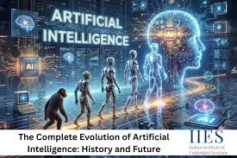

Envision a machine capable of learning, reasoning, and tackling challenges in a manner similar to humans. That captures the very heart of artificial intelligence. AI researchers aim to create machines that can think like humans. The journey has been lengthy and circuitous, marked by significant progress, setbacks, and periods of reflection.
In essence, artificial intelligence encompasses the techniques employed to create thinking machines. Systems capable of learning, reasoning, and adapting while executing tasks that typically demand human intelligence. Artificial intelligence (AI) can make computer-based natural language understanding, image recognition, and decision-making a reality.

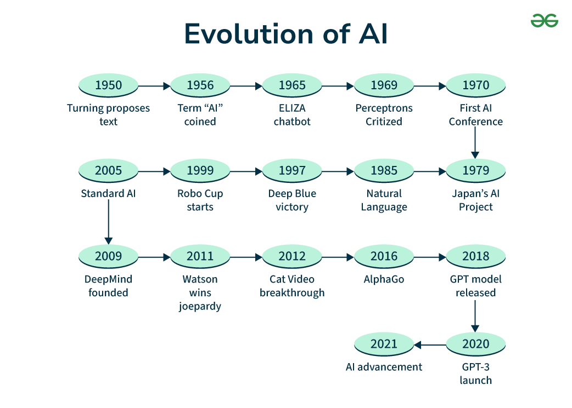
The article primarily focuses on artificial intelligence. This article examines the origins, current advancements, and future potential of artificial intelligence.

Introduction Of Artificial Intelligence (1950s-1960s) The 1950s, where the following events took place, are referred to as the period of inception for AI: 1950: Alan Turing's paper titled 'Computing Machinery and Intelligence' was published in 1950; introducing a test to measure machine intelligence called the Turing Test. 1956: A milestone in research relating to AI takes place in 1956 whereby the term Artificial Intelligence is first coined by John McCarthy in the Dartmouth Workshop. 1950s-1960s: Symbolic reasoning was used to encode human knowledge within logic-based computer programs; this was the objective of early artificial intelligence (AI) research. Slow Advancement: Rapid progress was difficult due to resource limitations. Early AI systems: An attempt was made to encode human knowledge using logical reasoning. Early development of artificial intelligence (AI) systems using logic and symbolic reasoning was slow due to the lack of resources and computational capacity.
The early years of AI, from the 1970s to the 1980s, were a mix of progress and difficulties.
In 1970, the 1970s brought the rise of Expert Systems, which were designed to mimic
the knowledge of specialists in different areas. Data scientists developed rule-based systems
that could solve problems by following predefined rules. However, these systems had
limitations. They struggled with uncertain or complex situations, which restricted
their usefulness. During this time, there was also an "AI Winter" from the 1970s to the 1980s.
This was a period of reduced interest and funding in AI research, largely
due to unmet expectations and a lack of financial support.
The Era of AI: Deep Learning & Neural Networks (2000s-2010s)
In the 21st century, deep learning and neural networks became a major focus of research:
Deep learning is a type of machine learning that tries to imitate how the human brain works.
It uses layers of artificial neurons to process information.
Deep Neural Networks: These are networks with multiple layers that have been very successful in tasks like image recognition, natural language processing, and gaming.
Advancements: Deep learning led to major improvements in speech recognition, natural language understanding, and computer vision.
Company Contributions: Tech companies such as Facebook, Google, and OpenAI played a big role in advancing AI research.
Artificial Neural Networks: These advanced algorithms, inspired by the structure of the brain, drive the progress in deep learning. AI gives us many chances that are much bigger than what we can imagine. Also, AI systems that can learn and solve problems need to think clearly and come up with new ideas, and work with the world around them. Think about an AI doctor who can not only find out what's wrong with a patient, but also understand and care about how they feel.
But there are some difficult things to deal with before we get to that future.
People are already thinking about the right and wrong things that could happen with smart AI. There is hope that one day humans and advanced AI can work together well and help each other out.
2.2 Concept of AI Generalist

A generalist in artificial intelligence is someone who uses AI to do tasks that once required
the expertise of multiple specialists. Instead of spending years studying to become an expert
in just one field, they use AI technology to gain knowledge and skills in many different
areas within a short period of time.

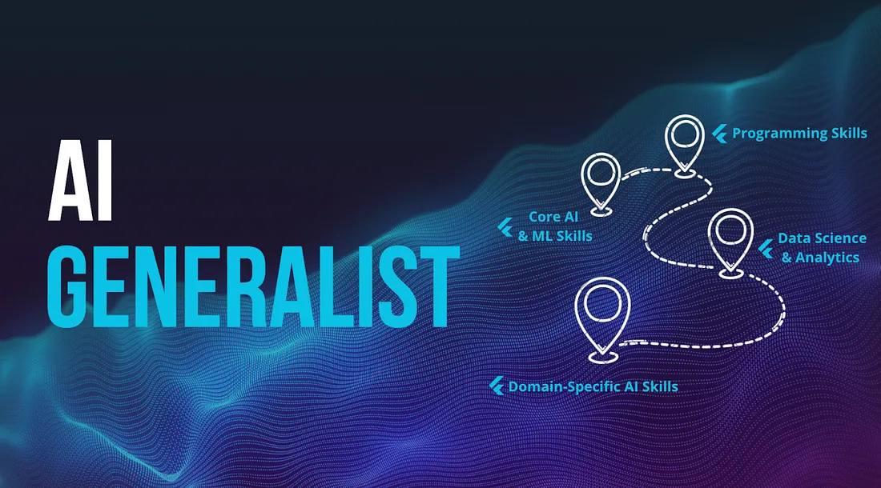

Quite honestly, I think the rise of AI generalists makes a lot of sense to me. The world
is full of different situations, so why not have AI be just as varied? Generalists
have an advantage because they can adapt and handle a wide range of tasks.
I've seen firsthand how generalists can be really useful in tricky situations. Here's why:
Life is hard to predict. Most problems don't have a single, straightforward solution. For
instance,a friend of mine was creating a tool for farmers to track their crops. He needed
image analysis to spot plant issues and also NLP to explain the findings in the right language. Generalists were able to handle both parts because they had a broad set of skills.
Having a variety of skills is actually a big advantage. You don't always have the resources
to hire experts for every task. Often, you have to do a bit of everything. Sometimes it's about organizing data, and other times it's about setting up a basic model.
AI Generalist Essential Skills:
Starting with AI Generalist Essential Skills might feel overwhelming at first, but you don’t need to master everything.
Instead, you should have enough knowledge in each area to understand how and where to apply different techniques.
a. Fundamental Skills (Must-Have Skills):
- Basic statistics and probability
- Basic Python programming
- Machine learning basics: understanding the differences between supervised and unsupervised learning, overfitting, and model evaluation techniques
- Natural Language Processing: text analytics, sentiment analysis, and chatbots
- Computer Vision: image recognition, object detection, and optical character recognition (OCR)
- Generative AI: tools like ChatGPT, DALL-E, and Midjourney
b. Advanced Skills (Nice-to-Have Skills)
Beyond technical skills, AI Generalists should also have:
- The ability to understand user needs and develop MVP (Minimum Viable Product) solutions to solve real problems
- Skills in managing data pipelines and deploying machine learning models
- Experience with APIs and a basic understanding of cloud computing
- The ability to translate technical insights into business value
Tip: Start by working on a single project that combines multiple AI areas.
For example, my first project was creating an automated customer service chatbot using Natural Language Processing, Computer Vision, and Speech AI techniques.

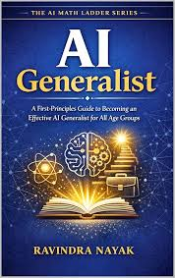

Why Do We Need AI Generalists For the Future?
Looking ahead to the years 2026 to 2030, the world of AI is set to change how businesses
operate, making experts who understand the challenges of AI very important.
a. Future AI Landscape 2026-2030:
The next five years will be a time when AI is fully integrated into every part of different industries.
Right now, 78% of companies have already started using AI in at least one part of their business. By 2030, AI will be a part of every business process. The global market for AI technologies is worth around $391 billion today, but it is expected to grow to over $1.81 trillion by 2030.
b. New Technologies Influence:
Agentic AI will allow machines to make complex decisions on their own.
Multimodal AI will combine text, speech, image, and video technologies into one system.
Edge AI will bring smart capabilities directly to devices and sensors where they are needed.
Quantum-enhanced AI will solve problems that were not possible before.
c. Required Future Skills:
Being able to use AI across different areas at the same time. Designing and improving
how humans and AI work together. Creating AI that is fair and free from bias. Managing
and fixing AI systems in real time.
d. Future Job Outlook:
By 2026, AI is expected to create up to 97 million new jobs.
However, the kind of work these jobs will involve will change a lot.
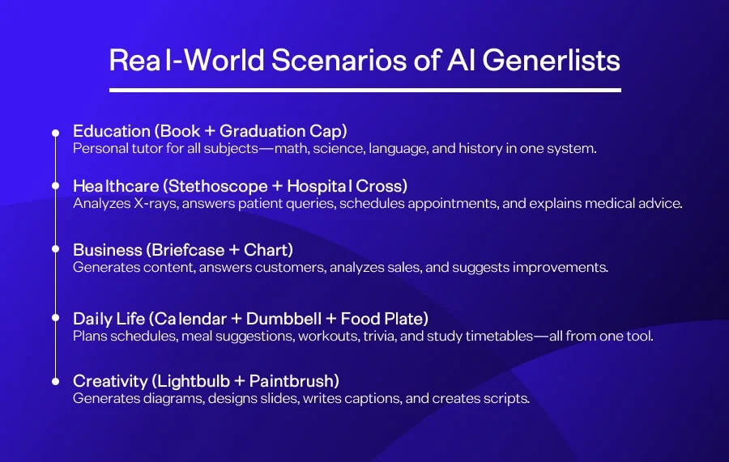

Human capable of operating every train or deployment function of an AI gadget while having a legitimate clinical and commercial enterprise history. A generalist AI is not always limited to an unmarried way of doing AI, does not want the knowledge of a specific professional.
Superior measurable processes.
Running AI tasks and giving them to exec and engineers in an ROI focused way.
AI is a tool that allows a person to manage multiple duties in harmony. A software can take care of any work required from content material advent to search engine optimization to administrative painting. One person could undertake the workload of the content department, admin department, and search engine optimization department all through themselves.

Four Essential Competencies of the Generalist AI
In today's digital world, four key skills set apart those who thrive in the new economy.
1. Application Development Skills
The current wave of AI technologies is making app development more accessible.
With AI-powered tools like Bolt and Cursor, you can create functional apps in just a few hours.
2. Process Automation Skills
It's not just about simple automation — build smart workflows that can learn and improve over time.
3.Innovate
Use AI to boost creativity and produce high-quality designs, content, music, and presentations.
4. Networking Skills
Build your influence in the AI era by networking effectively.
Use personalized outreach, content creation, and thought leadership to stand out.
2.3 AI Technologies Used in Content and SEO

Various AI technologies are rented via educational institutions to maintain their visibility and control.
Generative content platforms: Technologies like Magic School AI allow for the automated creation of lesson plans and introduction of worksheets, while others assist with overly high-quality visual content materials, such as Canva for schooling.


Search Everywhere Optimization (search engine optimization): SEO has regularly changed from targeting key phrases to optimizing for AI Overview and Agent Search on structures together with ChatGPT, Gemini and Claude.
Technical and on-Page tools: Tools like Surfer SEO and Rank Math make use of AI to generate schema markup and meta tags mechanically, thereby making the content "gadget-readable" for search engines like google.

AI and Its Impacts on SEO and Content Marketing AI was once thought to be a technology
for the future, but now it's here. Today, marketers use AI in digital marketing to understand
how search engines work, how customers behave, and then create better content.
Here's a simple comparison:
Aspect | Conventional SEO | SEO With AI Technology
----------------|-------------------------|-------------------------
Keyword Research | Requires time and effort | Uses AI for keyword research
Content Generation | Written by hand, takes time | AI helps generate content
Updates to SEO | Reactive approach | Uses predictive analysis and machine learning for SEO
Monitoring Performance | Basic analytics | Real-time monitoring using AI

SEO Automation with AI: A Game-Changer

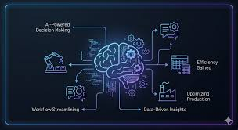
One of the most significant benefits of integrating AI is SEO automation with AI. Tasks like meta tag generation, backlink analysis, technical audits… & even internal linking can now be streamlined.
By using machine learning for SEO, marketers can analyse massive data sets, predict search trends… & automate strategies that would otherwise take weeks.
If you’re keen to master these skills, check out this Digital Marketing Program designed to equip you with the latest AI tools & strategies.

SEO Automation by AI – A Game Changer
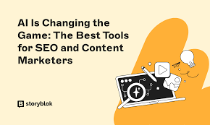
Incorporating AI into any business venture brings significant benefits, especially when it comes to automating SEO processes. Tasks like meta tagging, backlink building,
technical audits, and internal linking can now be handled automatically through AI.
With AI, marketing experts can analyze large volumes of data, spot upcoming SEO trends, and automate strategies that once required weeks of manual work.
2.4 Role of Machine Learning and NLP

Machine Learning:
Machine learning is a part of artificial intelligence where algorithms are designed to find
patterns in data. This technology allows algorithms to predict new information that is similar
butnot exactly programmed by humans foreach specific task. Machine learning is used for many purposes like recognizing patterns and processing language.
Works well with large amounts of data: Machine learning can handle big data and find patterns that people might miss. It can learn on its own and adjust to new situations over time.
It helps in making better decisions by using data predictions, like knowing what customers
might do or spotting fraud. It gives personalized suggestions, like how Netflix, YouTube,
or Amazon recommend things to users.
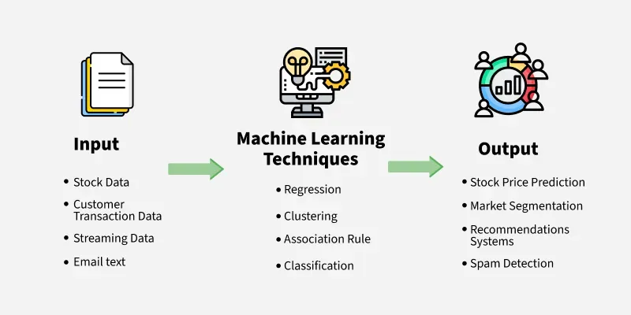

Machine Learning Methods Types
There are three main types of machine learning methods, depending on how the learning
Process works and the type of data used.
Supervised Learning
In this method, training happens using labeled datasets where both input data and the corresponding output are known.
The goal is to find the relationship between inputs and outputs so that predictions can be made about new data.
Common tasks in supervised learning include classification, regression, and prediction.
Unsupervised Learning
This method uses datasets that do not have predefined outputs. The main task is to find
Hidden patterns or groupings within the data. It is often used for clustering, reducing the
number of features, and detecting unusual data points.
Reinforcement Learning
Learning occurs through decision-making and interaction with an environment.
An action is taken, and its success is measured by a reward or penalty.
The aim is to find the best strategy that leads to the highest overall reward.
This approach is commonly used in robotics, automatic control systems, and video games.

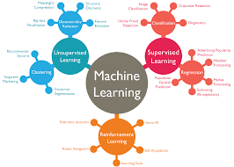

Natural Language Processing (NLP)
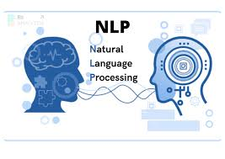

NLP is a part of computer science and AI that uses machine learning to help computers
understand and work with human language.NLP allows computers and digital devices to recognize, understand, and create natural language, like text and speech. This is done through
computational linguistics, which uses rule-based models, statistical methods, machine
learning, and deep learning to study human languages. NLP research has played a key role
in the development of generative AI, thanks to the ability of large language models and image
generation tools to follow user instructions. Today, NLP is part of many everyday technologies, such as search engines, chatbots that help with customer service through voice, voice-controlled GPS navigation, and virtual assistants on smartphones like Amazon's Alexa, Apple's Siri, and Microsoft's Cortana.
Furthermore, NLP is becoming more common in enterprise software solutions that help
improve business processes, increase employee productivity, and streamline operations.

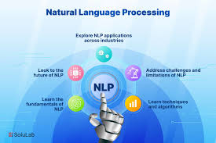

By allowing people to talk and work with machines using the everyday language they speak, NLP makes it easier for humans to interact with machines. There are many advantages to using NLP in different areas. Automation of repetitive tasks Data analysis and better insights
Improved search results Creating content Automation of repetitive tasks NLP helps with
tasks like customer service, entering data, and managing documents. Chatbots using NLP can handle customer questions automatically,so human workers can focus on more complex tasks. NLP also helps with organizing and pulling information from text documents. It also makes language translation easier, allowing text in one language to be translated into another.
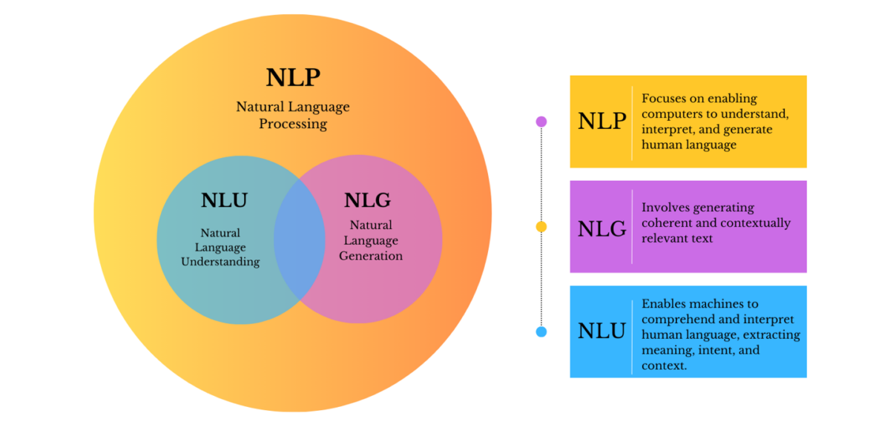

Chapter 3: Content Creation in the Education Sector

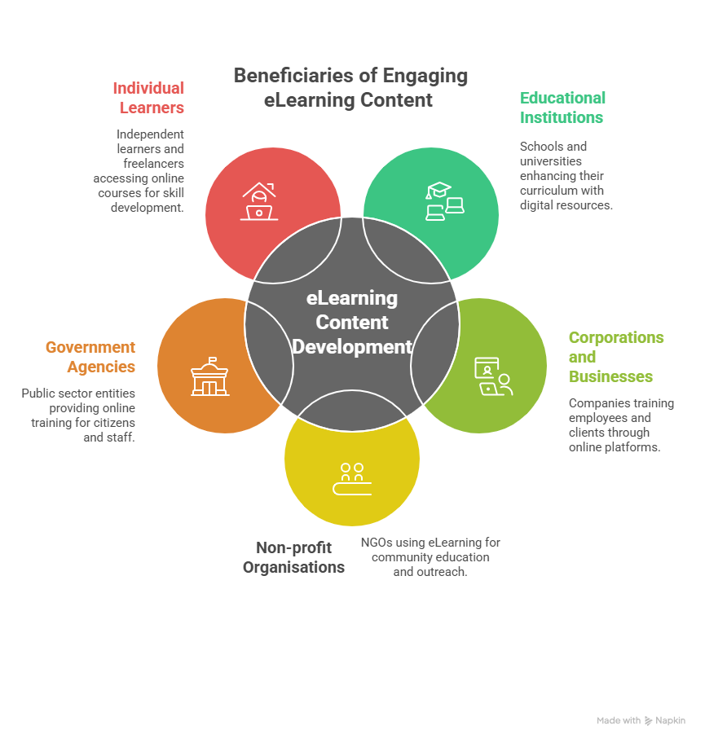

Creating educational content is a process full of creative ideas and exciting opportunities.
This guide will show you how the process works and the benefits of creating engaging
educational content. Whether you're a teacher, someone making learning materials, or simply someone who enjoys sharing knowledge, this article will take you through the world of creating educational content. It's a unique and special way to share
information and inspire others. Content creation in the education sector plays a key
role in shaping the future of learning. It's about sharing knowledge in a way that captures
students' interest and encourages them to keep learning more. Our approach ensures
that learners are not just receiving information but are truly involved in the learning
process through well-designed educational content. It also allows for tailored learning
experiences that match how different students best take in information. Additionally, creating
strong curriculum content helps students develop their ability to think critically, which is important for facing challenges they might meet later in life.
3.1 Types of Educational Content


By 2026, AI generalists will create all sorts of educational material. They can make
interactive teaching tools using Edcafe AI and Curipod to build bigger slides, quizzes, and surveys. They can also make learning easier with Diffit, which helps reduce the
difficulty of learning. For multimedia resources, they can use Synthesia and Canva Magic Studio to create videos, avatar-based training, and infographics. AI can also help with
managing doctors' schedules and creating lesson plans using Magic School AI.
For search engine marketing, they can write blog posts, articles, and landing pages
to bring more visitors to education websites. Educational content is what teachers create
to help, inspire,and teach students. This means that learning doesn't always need books or traditional classes. Educational content can be made to fit the needs of each learner.
Educational content is usually flexible, easy to use, and helpful. It should be made to support
the goals of learning. For example, educational content can be used to teach the same
topic or story to learners of different ages. If you're teaching a mother and her son about the basics of English, you can change your lesson plan. You might use interactive
activities to help the younger child understand, while explaining how English is used in social
media, news, and messages to teach the mother.
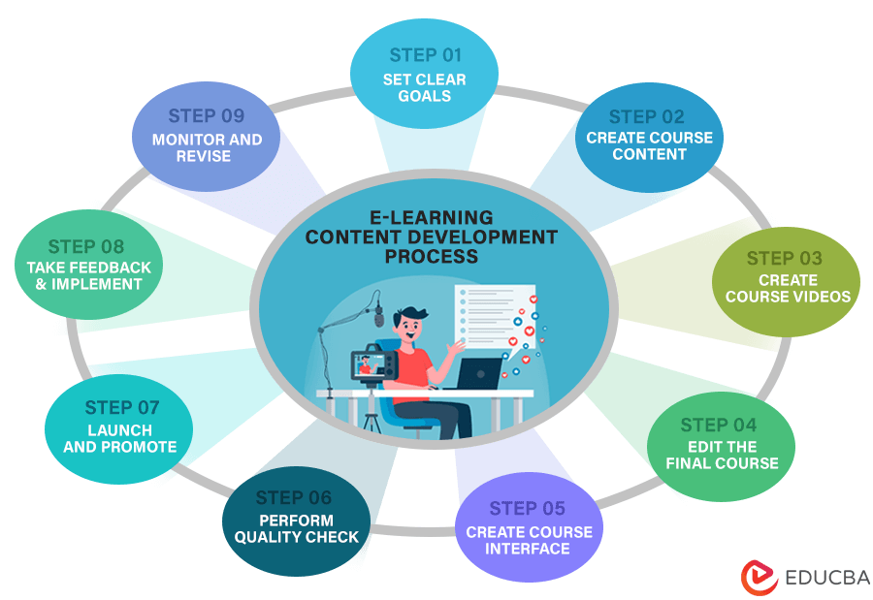

What Makes Teaching of Content Important in Education?
Educational content is very important in today's education system because it helps people learn better and more easily. Here are some reasons why it is so useful:
Learning becomes easier because educational content gives learners access to information and helps them understand new things quickly. It is also convenient because digital content can be used anytime and anywhere, making learning more flexible. People can learn at their own pace and in a way that suits them best. Digital content is usually cheaper than
buying books or other teaching materials. It also keeps students interested by using videos, images, and quizzes. Digital content can be updated quickly to include the latest information.
Learners can choose to study topics they are interested in. Educational content also helps
track how well someone is learning. Using digital content helps protect the environment by
reducing the need for printed materials, which is good for the planet. Teachers and schools
can see how students interact with content and improve it over time, making learning
more efficient. It also supports learning from a distance, which is helpful during
emergencies or for people who can't go to school in person. Educational content can be
shared among students, teachers, and schools, encouraging teamwork and the sharing of
resources. Finally, digital content supports lifelong learning by providing a wide range of materials that people can use throughout their lives.

3.2 Content Creation: Traditional vs. AI-Driven
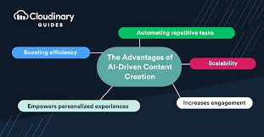
AI-based content creation in education is usually very efficient. Teacher Input (minutes): The teacher gives the necessary details like the topic, grade level, content type, difficulty
level, and how it matches educational standards.
AI Generation (seconds): The system quickly creates different types of content such as multiple-choice questions,
worksheets, answer keys, and tests.
Teacher Revision (minutes-hours): The teacher looks through the content and makes any needed changes.
Content Deployment (instantaneous): The content is immediately sent to students.
For example, the platform Edu Genius has made this process easier for teachers from
primary to secondary levels. It can create over 15 types of educational materials, including
multiplechoice questions, flashcards, worksheets, mind maps, essays, case studies, presentation slides, and concept summaries. These materials automatically align with Bloom's Taxonomy and can be exported in various formats like PDF, DOCX, PowerPoint, LaTeX, and HTML.

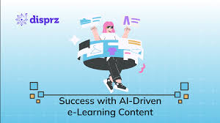
With AI-generated content, the function of the coach is also changing.
Speed ​​​ & Scale: AI produces content with charging exponentially faster than conventional methods. Personalization: AI adapts and customizes content material based entirely on the needs of the learners. Workflow: AI can assist the coach in brainstorming and sharpening content material.
3.3 Advantages of AI in Content Development
Artificial intelligence is currently transforming many industries, including education. The use of AI in education has brought about several changes for both students and teachers. Some of the key effects include better teaching methods, more efficient management of learning institutions, and enhanced learning outcomes.
AI content generators provide many advantages and chances. They help content creators and marketers work faster and better, allowing them to make messages for different marketing
platforms. As a result, they can save time, money, and effort. Looking ahead, the future of
this technology looks very encouraging and could change how quality content is made
and used.AI is likely to become part of more industry tools, making it even more useful
in marketing and other areas.
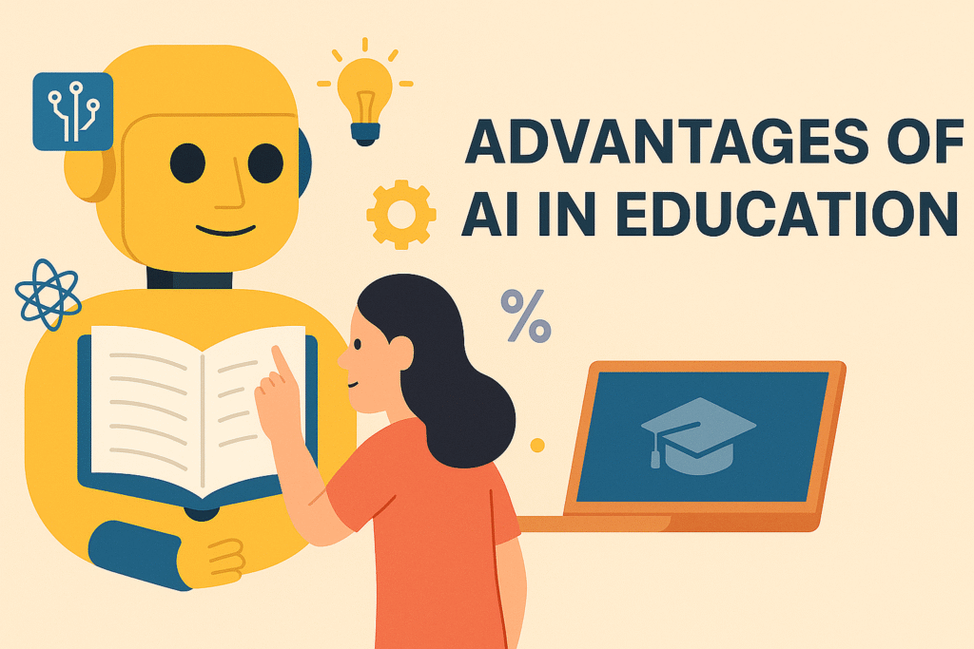
One significant impact is the personalization of education.AI allows teachers to tailor
courses to match the individual abilities of students. This is made possible through
advanced algorithms that assess students' strengths, weaknesses,and preferred learning styles.

Immersive learning experiences
The use of artificial intelligence in education opens up possibilities for creating more engaging and immersive learning experiences.
Technologies like VR or AR can help learners explore simulated environments and
situations, allowing them to interact with objects and scenarios that might be challenging
or costlyto experience in real life. For example, students could virtually visit historical locations, conduct science experiments, or practice speaking foreign languages through AI-driven
avatars, providing a distinctive and memorable learning experience that boosts understanding and retention.
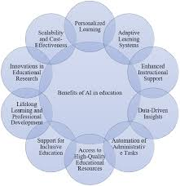
Student engagement and motivation
Developing immersive learning experiences through AI can also boost student
engagement and motivation.AI-enhanced gamified learning platforms merge educational
content with game-like elements such as scores, rankings, and challenges, making learning
more interactive and competitive. Additionally, AI can offer instant feedback and
personalized support, helping learners stay focused and motivated throughout their studies.
Economic efficiency in learning
AI technology can improve the economic efficiency of the learning process by automating tasks and offering scalable learning opportunities.
For example, AI can automate processes like grading written assignments and managing student records. This allows educators to focus more on teaching. Additionally, intelligent learning platforms powered by AI can reach a large number of students at a lower cost. The ability to scale helps reduce the expenses involved in the learning process, making high-quality education more accessible and affordable.
Integrated learning approach and intelligent tutoring systems
Using AI technologies, intelligent tutoring systems can provide personalized support to students, sometimes acting as virtual tutors.
These systems use data analytics to assess how well students are performing and offer tailored recommendations. Specifically, intelligent tutoring systems can identify knowledge gaps, suggest suitable study materials, and adjust the difficulty of tasks to match each student's needs.
AI automation saves the coach’s effort and time. It increases student engagement, given that they find the content material interactive. Quality & consistency: We make use of the AI ​​equipment like Grammarly which will enhance the excellent material. Personalized Learning: Students’ Mastery Can Be Accomplished with AI’s Personalized Topic Advice

3.4 Challenges and Ethical Considerations

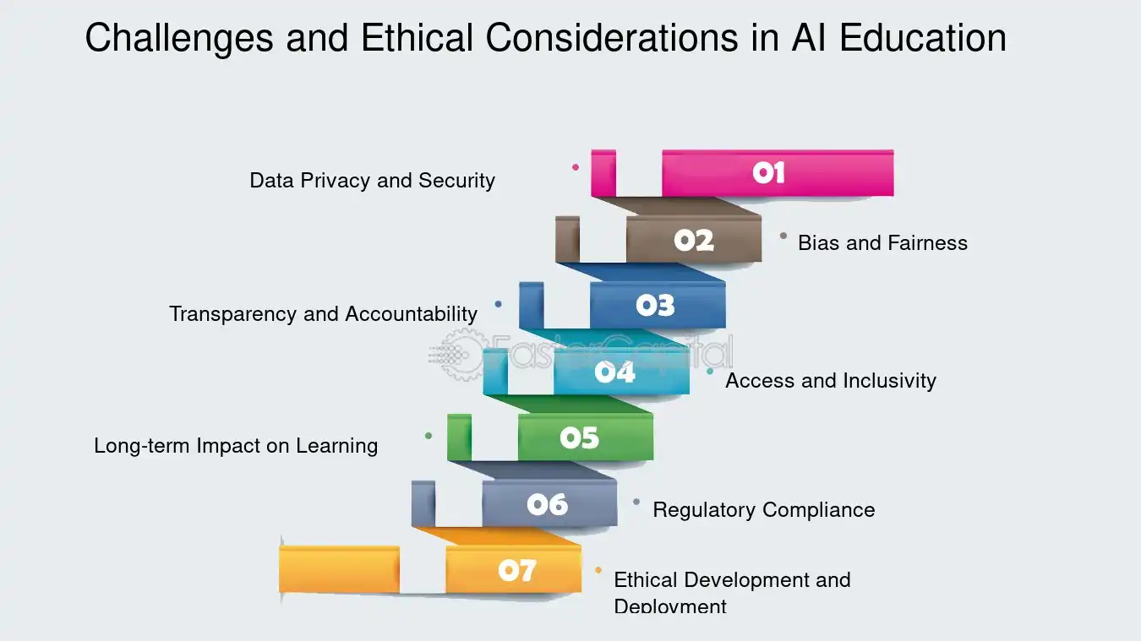
Bias & Accuracy: The information generated through AI models can be biased and unhelpful.
Data Protection & Security: There are detailed rules and policies that practice with student data.
Overdependence and lack of talent: Reliance on AI should cause lower levels of student talent.
Academic integrity: there is a problem of assessment to distinguish an AI-generated artwork from one with AI assistance.

By 2026, AI will be used to help teachers in terms of removing human language from schools.

Chapter 4: SEO Management in Education


SEO/Search Engine Optimization


It is the practice of improving or optimizing a website's visibility on search engines like Google, Bing, and others. As you rank higher in search results, there'sa greater chance people
will see and click on your pages. The goal of Search Engine Optimization (SEO) is to bring people to your website, where they can become customers, clients, or regular visitors.
What is the Need for SEO?

There are several reasons why SEO is important, including:
- Improving the quality of the website
- Increasing website traffic
- Making the site visible to others
- Enhancing user experience
- Gaining a competitive advantage
- Analyzing the website's performance
4.1 Basics of Search Engine Optimization


The way we implement search engine optimization in education in 2026: From keyword targeting to the AI-first "answer engine" and E-E-A-T (Experience, Expertise, Authority, Trustworthiness). AI-First Search (GEO): Generative engine optimization is now the key to appearing in AI overview (SGE) and voice search (Siri/Alexa).
Technical Search Engine Optimization: Websites want to be mobile-friendly, load fast (Core Web Vitals) and stable (HTTPS).
Topical Authority: Display your information about "on-line nurse applications" using "Topic Groups" (a column website supported using a series of linked sub-content pages).
4.2 Importance of SEO for Educational Platforms



SEO isthe process of optimizing a website to improve its visibility on search engine result pages. This practice helps institutions and platforms gain more exposure. The importance of Education SEO cannot be overstated, as it helps enhance the institution's online presence,
attract students, and make information more accessible.
An effective SEO strategy for educational websites involves keyword research, content optimization, and technical improvements. By focusing on relevant keywords, educational
institutions can create content that matches the search queries of their target audience, which in turn can help them rank higher on search engines. This increased visibility can drive more traffic to the website, helping the institution build credibility within its niche.
At its core, Education SEO goes beyond just optimization techniques—it involves
understanding the inner workings of the education sector. With more students relying
on online platforms for information, mastering Education SEO is essential for any institution aiming to stay competitive. In this article, we will provide a detailed guide on how to implement SEO for educational websites, along with practical insights and data-driven strategies to help your institution rank higher in online searches.

Useful Tips for Higher Education SEO to Rule Rankings


Here are some useful SEO tips for your higher education website to get ranked on the first pages of search engines.
Start with an SEO audit of your website to assess its strengths and weaknesses, along with optimization issues for both search engines and users.
Make Use of Relevant Keywords: Use keyword research tools to identify the organic keywords that prospective students are searching for, including both general and program-specific terms.
Make Your Business More Visible on Local Searches: Include geographic keywords to appear in searches with local intent.
This helps students looking for institutions in your area.
To boost your rankings and convert visitors, it’s time to create engaging content That
showcases your programs, faculty, and campus life. Make Sure Your Website is Mobile-Friendly: Over 50% of website traffic comes from mobile devices.A responsive design
ensures a good user experience and better SEO ranking.
Make Your Website Easy to Navigate: A user-friendly site structure with clearly identifiable
categories helps in reducing the bounce rate.
Make Use of .edu Domains for Credibility and Good Rankings: These domains are often
favored by search engines and typically get better rankings.



4.3 Keyword Research and Content Strategy

2026 requires a keyword approach based entirely on motive no longer just search scope: Intent Mapping: Identifying whether searchers want to research facts (e.g., 'a way to grow to be a teacher') or are ready to apply (e.g. M in2, 'check for2'0d). Conversational and long-tail Keywords: Focus on what students will ask while speaking aloud (e.g. "what are the job outcomes for a statistical technical knowledge"). AI Content Generation: Use AI for structured lesson plans, interview scripts for movies, and quizzes from one question activate. Human-in-the-Loop: Let educators evaluate AI generated content for accuracy and educational foundation so that it meets E-E-A-T indications.

4.4 On-page and Off-page SEO Techniques

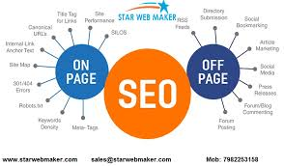

On-site search engine marketing (AI-Assisted): Utilize AI equipment consisting of Surfer seek engine ads and Rank Math to optimize meta titles, meta descriptions, and header tags (H1-H3) for click through cost (CTR). Use FAQ, FAQ for keyword rich targeted feature snippets. Off page search engine advertising: Involves getting fine, unidirectional lower back links, mainly of an .Edu, or .Gov internet site, an academic journal, a medium as they can serve as a 'bid signal' for AI.
Local Search Engine Optimization: Crucial for businesses with a campus presence, as the search term used will usually include 'near me', therefore optimized Google business business profiles and localized content webs are a must.
SEO best practices keep changing because of how internet users behave and what's popular now. Today, the best way to do SEO is by making a good plan that covers both on-page and off-page things.On-page issues are mainly about creating top-quality content and making sure your website works well technically.
This means making your site fast, easy to use, and including keywords in the right way.
For off-page practices, the main thing is getting high-quality links from other websites.
This helps search engines see how relevant your page is, which can help you rank better.
Becoming an On-Page and Off-Page SEO Expert
Having good SEO skills can help any serious digital marketer.
To become really good at SEO, you should take a proper training course. If you're interested in learning more, check out the professional diploma in SEO offered by DMI.

Chapter 5: Role of AI Generalist in Content Creation

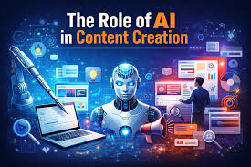

An AI generalist, as well as a combination of ChatGPT, Claude, and specialized educational tools, can manipulate the complete method of content material technology.
5.1 Automated Content Generation

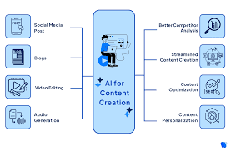
AI stands for artificial intelligence and is a complex part of computer science that focuses
on building systems that can mimic human thinking and decision making. It uses various
methods like machine learning, neural networks, and natural language processing.
These methods help in analyzing data, making predictions, and learning from information.
A lot of big achievements have been made in AI research, and today, it has many advanced
applications in areas like image recognition, speech recognition, robotics, and understanding
human language. AI is continuously changing our lives and becoming more common
in many areas of life. One area where AI has a big impact is content creation. Content
creation involves many steps, like gathering and analyzing data, organizing information,
and publishing articles.But with the help of special AI tools, this process can be made much
easier because machines can handle many routine tasks. For example, content generators can create different types of text, such as blogs, articles, poems, and even scientific papers.
Also, content curation helps by offering personalized content based on user behavior and preferences. Finally, chatbots make it easier to communicate with people.

AI greatly cuts down the time desired for content creation by coping with repetitive and large commitments. Automated quizzes and flashcards: Tools like Quizlet use AI to create practice tests, flashcards, and detailed notes. Study Guides and Annotations: AI can take long textbooks or lecture transcripts and turn them into concise annotations. Course Structure Builder:AI-powered systems can describe management modules, definitions, and getting to know objectives based on a topic.
5.2 Personalization of Learning Content

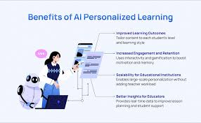

Using AI technology to tailor content isa way for marketers to better the customer experience and boost sales. By looking at a visitor's past actions, likes, and other information, AI can create highly personalized content for each person. A survey by Epsilon found that 80% of people prefer buying things that offer a special experience. Smart landing pages that use AI can change themselves based on what a visitor likes, which can help more people take
action. According to a report by Instapage, using these smart landing pages can raise
conversion rates by an average of 22%. Another example of personalization is the recommendation systems used by Netflix and Amazon. These systems use AI to give customers content that is specifically suited to their tastes, helping them stay
interested and loyal to the platform. For instance, Netflix's recommendations look at the movies people watch, rate, or like to provide very accurate suggestions for each viewer. A personalized approach has been a main reason for Netflix's success; 80% of the content watched on Netflix is suggested by AI.
A way that systems regulate classes? They watch how fast a student moves, what they like, how nicely they do - so they finish things class by class. This transition quietly draws students in deeper, regularly increasing interest rates between 10% and 20%. Small changes, real impact.

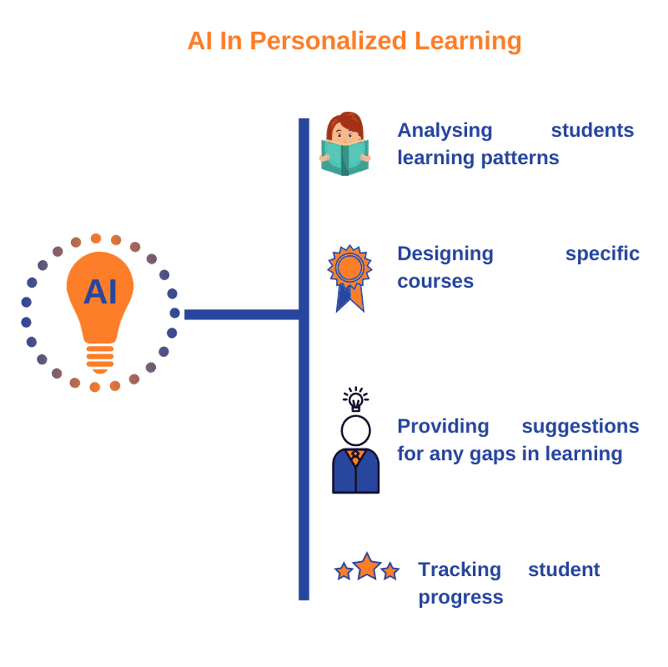

When gaps appear, the AI chooses certain topics that healthily what the student misses and adjusts as it goes instead of sticking to at least one fixed plan.
Learning moves at your pace when equipment along with Khanmigo steps in with custom control. Hints shift gently to match how closely you pull each concept. What feels difficult one day gets simpler the next, quietly adjusting behind the curtains. Every nudge comes timed just right, no longer too soon, not at all delayed.
When it comes to getting to know, language boundaries begin to fade. Devices powered by artificial intelligence transfer sentences from one language to another on the fly. Real-time changes show up immediately. Content matches local speech patterns, not just vocabulary. Education flows quietly across borders. Understanding grows even though the mother tongue is different. The message stays clear through automatic shifts in phrasing. Learning opens where it was as soon as it was locked.
5.3 Content Optimization Using AI



Applications like ChatGPT and Copy AI can mimic human thinking and language skills.
This means they can help create high-quality content, such as headlines, calls to action,
meta descriptions, blog posts, articles, and landing pages. By using research on what
audiences like and what content works best; AI can quickly produce a first draft of well-optimized content. Plus, with data analysis, AI can make content that matches what customers are searching for online. However, before publishing, it’s important for skilled
human writers to review and improve the AI-generated content to make sure it's the best it can be. Smart equipment pushed via artificial intelligence helps gain knowledge about material that shows up more frequently in online searches. What seems over the top tends to get noticed first when humans look up issues. Start strong by knowing what humans honestly type into search engines like google. Tools that include SEMrush dig into those queries, revealing exactly what customers want. Surfer SEO takes it the same way - recognize companies of related terms that fit together obviously. Instead of guessing, those systems guide changes directly to the website. Clear patterns emerge as you see how words connect across top-ranking content.
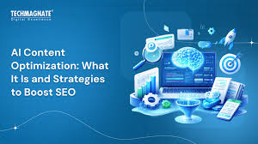
Outdated categories get refreshed via smart software, keeping them modern. Search engines notice when information is still up to date. Which adjustment is how quickly corrections occur. Old pages benefit from new accuracy without tutor experience. Updates appear silently in inheritance. Frequent processing helps in higher online visibility. Accuracy varies slightly over the years. Information sessions - technology responds.
Titles and meta descriptions created with the help of artificial intelligence generally tend to attract additional clicks. What happens is machines learn what works, so craft fragments people undoubtedly respond to. Sometimes it's about word choice, now and again rhythm, persistent experimentation pays off. Click go up while the message feels find it irresistible become made only for you. Behind every line sits code trained on mountains of user behaviour facts.

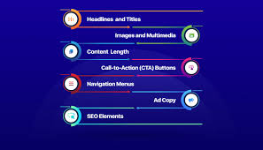

Why Does AI Content Optimization Matter?

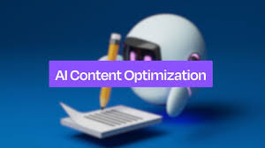
The digital world is always changing, with more devices, websites, social media, and blogs than ever before. Because of this, businesses need to keep updating their
content creation and optimization strategies to stay ahead of the competition. Whether the content is made by machines or people, AI can help with research, finding the right keywords, creating titles and subtitles, adding links, and organizing data. If AI is used to create content, it’s still important to have a human editor check it. Humans can make changes to improve the tone, style, and overall voice that represents the brand. However, when AI helps gather information for long reports or briefs, copywriters can write content that needs less editing from humans.
Data-driven content strategy
Before writing content or making plans, it’s important to collect and study useful data.
This can take a lot of time because it involves looking through social media,
surveys, website visitors, and other online sources. Luckily, AI tools can help collect and
analyze data quickly, giving deeper insights into what the target audience needs and prefers.
5.4 Case Examples in Education
Learning gets a boost when conversations feel real - faith to talk to smart assistants who adapt as you go across. These discussions allow mistakes to turn into guidance without judgment. Imagine answering questions, then getting clear reasons for why something works - or doesn't. Instead of 1-length-fits-all exercises, vary your answers based on how you think you studied. Training becomes less repetitive, more like test runs for real communication. Guidance appears immediately after answers, slowly shaping understanding.

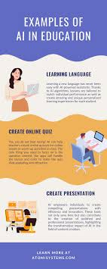
Out of nowhere, CYPHER Learning jumps into action producing publications and routinely testing the use of synthetic intelligence. Across more than fifty languages, it shapes materials to match the way each person learns. The skills training guides what looks like, making things feel personal without extra effort. The language is not a wall - the content changes easily, no matter what language you speak. Behind the scenes, intelligent systems regulate pieces based on development done so far.
A man who teaches you how to research - Carnegie Learning adjusts on the fly, shaping answers in math and technology based entirely on what you get right or stumble through. One second it's guiding, the next it's stepping back, looking at patterns in real time.
Students try out realistic situations the use of simulations pushed through synthetic intelligence. These virtual spaces provide risk-free ways to gain experience through guided experiments. A virtual setup responds immediately and adapts as decisions unfold. Mistakes end up as part of gaining knowledge without real consequences. Training occurs internal dynamic models that mimic real conditions. The device adjusts primarily based on choices made second to second. Skills develop through repeated interactions in meaningful settings.

AI in Education: Universal Access
According to Bernard Marr, there are several ways AI technologies can help Make education accessible to everyone.
For example, AI can help create "global classrooms" where students can learn, regardless of their first language or any disabilities that might make traditional schooling difficult. It can also provide education to children who may not be able to attend school because they are sick. Additionally, AI can offer better access to students who need different learning
Materials or focus on subjects that aren't covered in their local schools. Overall, AI is expected to help teachers overcome various challenges that might affect a student's
learning, such as physical, intellectual, social, or psychological issues. This can ensure that all children, no matter their background, economic situation, race, gender, sexual orientation, or any physical or mental conditions, have equal access to quality education.

Chapter 6: Role of AI Generalist in SEO Management


6.1 AI-powered Keyword Analysis
Starting with extra than just how often humans search, AI generalists dig into meaning through tools like NLP. They draw close to what customers really want by probing between the lines of sentences written online. EICTA, IIT Kanpur
Later on, software that includes SEMrush research beyond styles. Ahrefs digs into shifts through learning topics. An example could be the introduction of synthetic intelligence into the classroom fabric. These systems detect movement early. Before a spike happens, clues really show up. Patterns emerge from ancient numbers. The rising interest is seen in fragments first.

When humans talk to smartphones out loud, artificial intelligence pays interest in how they phrase questions - like asking "How should I assemble for the JEE?" rather than writing quick sentences. Answers get fashioned around herb speech, no longer rigid search phrases. Long sentences written as normal discussion are more trusted now. Machines analyze from full thoughts, no longer fragments. What customers say topics like it sounds less robotic, extra human. Voice searches are not growing unpredictably, so systems adapt using listen differently. Instead of searching for individual words, the software follows that tag through concepts. The questions go category by category, just like real interviews do.
Starting with scattered thoughts, and synthetic intelligence type comparable subjects into dense systems. These collections form clear paths across a topic, guided through how beginners search. Instead of random pages, websites start displaying step-by-step information. One concept ends in another through natural hyperlinks created with the help of real questions asked by students. As patterns emerge, the content material connects more meaningfully - each piece supporting the next. The journeys evolve from interest to decisions without coercive steps. The structure grows quietly behind the curtain, driven by the help of machine estimation.
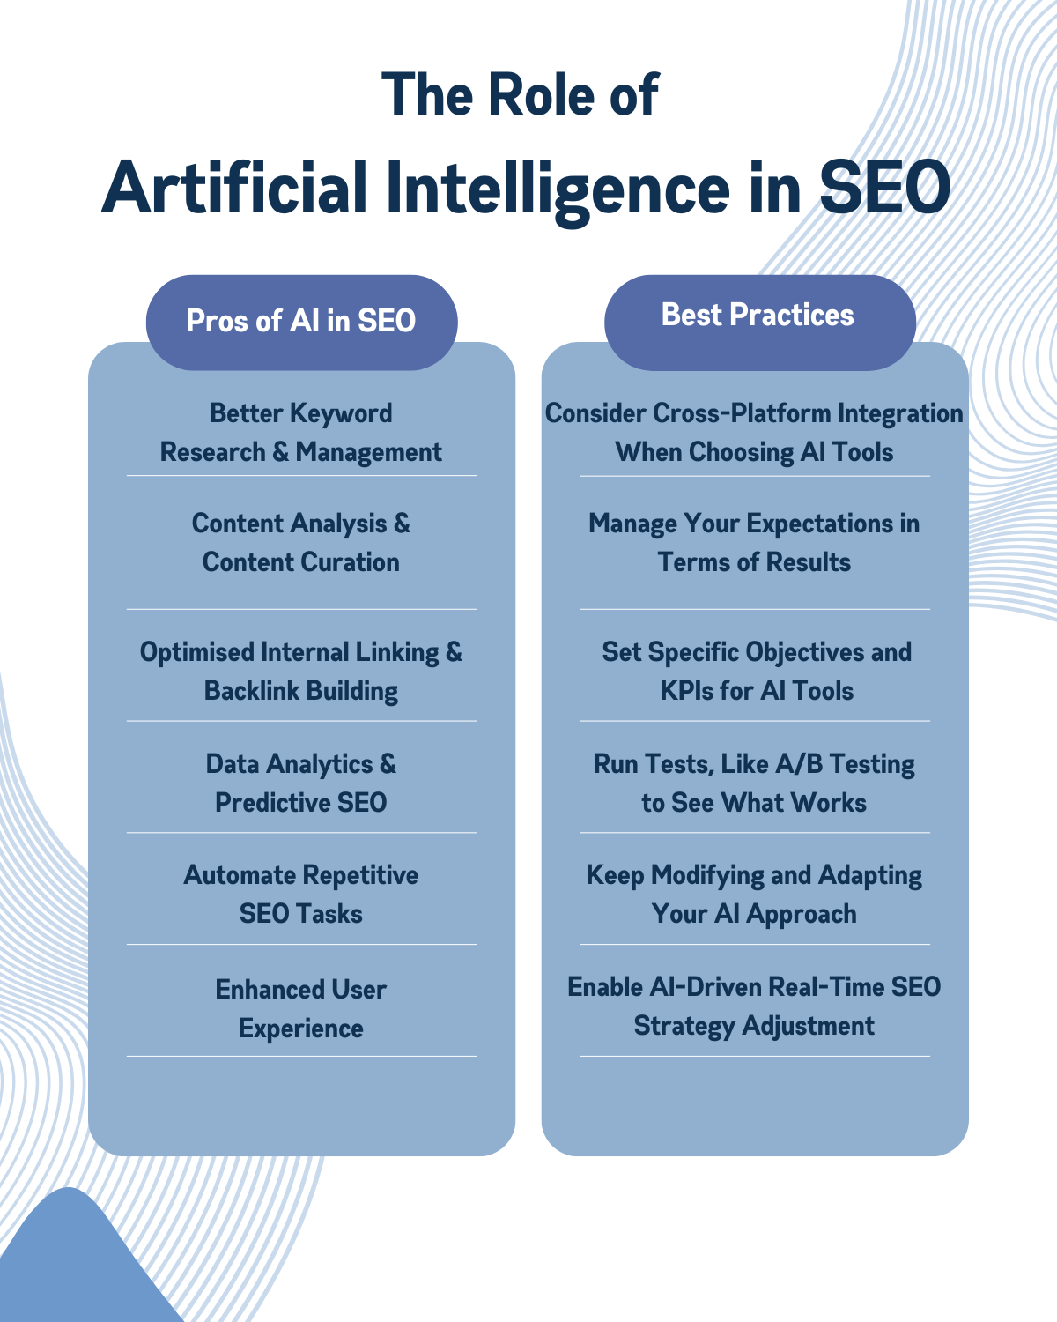

6.2 Content Performance Prediction

What if a machine could guess how well your words might do online? EICTA, IIT Kanpur watches as smart systems scan old posts and new drafts alike. Sometimes they peek at likely clicks. Other times, they weigh shifts in visibility before anything goes live
What grabs attention? Machines study how people act online. They guess what kind of material works best - maybe videos, maybe quizzes, perhaps detailed posts. Patterns show what keeps users involved. Not every format fits all. Some styles pull more views. Watching actions helps spot trends early. Past choices shape future suggestions. What worked before might work again. Focus stays on real behavior, not guesses.
Pages start slipping when they no longer match what people search for. Just like spotting students who might fall behind, systems can now spot fading web content before it drops off. Outdated info gets flagged by smart tools watching how well each page performs. Updates happen early because warnings come through patterns in engagement data. Traffic loss slows down when fixes arrive ahead of decline.
Snippets get tested by artificial intelligence, boosting click chances through trial runs. Educational links rise in clicks when smart systems preview how they appear on search pages.
6.3 SEO Automation Tools and Techniques


Marketers find more time for big-picture thinking when machines handle repetitive SEO work. EICTA, IIT Kanpur
Study materials such as guides, question sets, and lesson blogs now come together quickly through programs including ChatGPT and Jasper AI. These systems shape each piece to sound clear and serious without losing simplicity. One after another, outputs arrive ready for review, matching the needed voice every time. With steady precision, learning resources form in large batches while keeping a consistent manner. Each section reads naturally because smart software adjusts phrasing on its own. Real-time feedback comes through tools like Surfer SEO paired with Rank Math. Top results get studied automatically. Suggestions pop up based on what works - word usage, section titles, links inside pages. Changes appear live as you edit. What ranks high shapes each tip given. Patterns found in strong content guide updates made directly on your page.

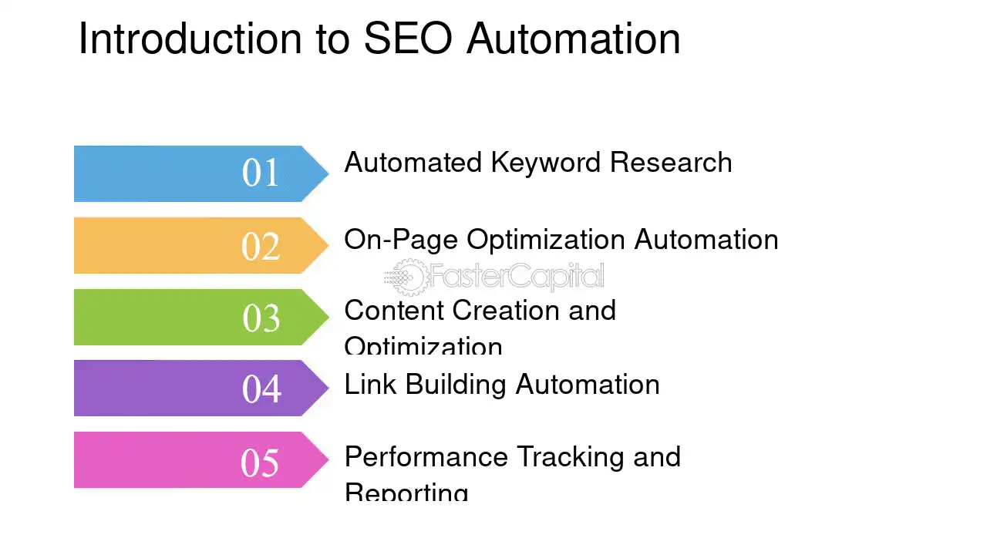

Tools run by artificial intelligence scan websites, spotting dead links without human help. When they find a course page, these systems build accurate structured data on their own. Image descriptions get fixed quietly in the background. Search bots understand pages better once adjustments are made. Readability climbs as hidden details align properly
6.4 Competitor Analysis Using AI
One way departments mock lack of learning? They look at what their opponents are offering online. Machines help sort through piles of tutors quickly. Some platforms drop topics that others head neatly. Technical assessments where material falls under. Seeing those holes getting closer solves them faster. The competitors often substitute, so it is risky to be blind. Looking at others helps to live in the right way. Gaps clearly show up when statistics do the search. Brands that ignore comparisons slowly lag behind
What if your department manager misses key search phrases? Tools powered using synthetic intelligence spot gaps - topics that others rank for but are still absent for your online website. Hidden patterns emerge when comparing contents insurance policies across institutions. One difference stands out: their approach is composed of terms you forget. The lack of these should suggest much less visibility. What is seen in rivalry effects may be what college students are truly seeking. A quiet transition occurs when those gaps are filled. Not magic - just higher alignment with real queries.
A way to increase the energy of a site? Look at who hyperlinks to competitors. Artificial intelligence scans these relationships, recognizing opportunities to earn useful education-related referrals. Instead of guessing, she finds openings that make discoveries. Every manager may want to suggest better online visibility. Some paths stand out after you see the whole picture.
Figuring out how human minds become less complex when machines check online feedback. Website reviews show what users don’t like about competing products. An incremental app can frustrate customers, and that element gets noticed. Social platforms monitor complaints that others avoid. Weak spots definitely come out through regular virtual listening. A terrible setup by one company risks improving another. Feedback spreads quickly, and styles emerge without asking. What buyers say in public often directly causes errors.
Chapter 7: Tools and Technologies
7.1 AI Content Generation Tools
These tools help you create personalized mastery checks, reproducibility marketing, and lesson plans.
- MagicSchool AI:
Magic School AI is a collection of tools made to help teachers with making lesson
plans, creating assignments, developing teaching materials, writing newsletters, and
doing other tasks. The service says it has over 60 AI tools that can save teachers up to 10 hours each week.
Benefits:
- It can automatically create content
- It makes content that matches teaching standards
- It works with 25 different languages
- It can rewrite content to make it easier to understand
- It offers tools for many subjects
Drawbacks:
- The AI only knows information up to the year 2021
- It can sometimes produce biased or incorrect content
Price:
- The teacher version is free starting from November 30, but future versions might offer paid options
- Schools can get a custom price
Alternatives:
- Eduaide AI (opens in a new window)
- Fetchy (opens in a new window)

- Canva Magic Studio:
AI-powered features in Canva help make presentations, photos, social media posts, and short videos. Some other new features are quick formatting, AI-assisted editing, and automatic text creation.
Pros
Canva makes many automatic designs and content quickly. It has AI tools that help
edit images fast. You can change file types, like from a document to a presentation,
languages, and sizes instantly. There are several AI tools that help with design work.
Cons
It doesn't make outputs as good as some advanced text-to-image and text-to-video tools. Sometimes the videos it creates might not be relevant. The free version
has limited access to AI tools.
Pricing
There's a free version with limited AI function credits.
Canva Pro for individuals is $14.99 per month, and for teams, it's $29.99 per month (charged monthly). Cheaper prices are available if you pay yearly.
Comparable AI Design Tool:
Adobe Firefly (free)

- Claude for Education:
Good at creating non-famous, first-class content, and works nicely as a research assistant for instructors.
When we launched Claude for Education, we introduced several new features:
Learning Mode:
This is a special way to use Claude that helps students think through problems on their own instead of just giving them answers.
It helps improve their ability to think critically.
Claude for Education University Agreement:
Claude is now available across campuses at universities such as Northeastern University, LSE, and Champlain College.
Academic Partnerships:
We are working with Internet2 and Instructure through their Canvas LMS to bring AI into teaching and learning.
Student Initiatives:
We started the Claude Campus Ambassadors program and launched the Claude API Credits Program for students.
- Curipod: -
Curipod is an interactive app that helps create lessons. Users can make their own
lessons or use theAI generator to create engaging and interactive lessons and activities like polls, word clouds, and drawing features.
Advantages:
It allows users to create interactive slideshows based on their lesson focus and
learning objectives. Students can follow along on their devices and engage by
drawing or participating in polls and open-ended questions. The app also uses
students' answers to generate a word cloud based on the responses.
Disadvantages:
It may sometimes generate irrelevant or incorrect information in the slideshows.
The app does not support exporting slideshows (this feature is only available in the paid version). There are also limited templates and galleries to choose from.
Pricing:
Freemium plan available. Individual premium version costs $9 per month, or $7.50 per month with annual billing. Custom pricing is also available for school districts.

- Grammarly:
Grammarly is an AI-powered writing assistant designed to improve spelling, grammar, and overall writing quality. It offers real-time suggestions for clarity, tone, and style, ensuring polished and professional content. Grammarly’s tone detector is particularly useful for maintaining consistent brand voice, while its advanced features, like clarity suggestions and sentence rewrites, enhance readability. The tool integrates seamlessly with browsers, word processors, and email platforms, providing versatile support for content creators.
Pricing
Grammarly offers a free plan with basic grammar and spelling checks. Its premium plan starts at $12 per month (billed annually) and includes advanced suggestions for style, clarity, and tone, as well as a plagiarism checker.
Pros
- Real-time writing suggestions for grammar, spelling, and clarity.
- Integrates with multiple platforms, including Google Docs, Outlook, and web browsers.
- Tone detection helps ensure content aligns with intended messaging.
- Advanced features like sentence rewrites and plagiarism detection for premium users.
Cons
- Free plan lacks advanced functionality, such as tone and style checks.
- Suggestions can occasionally disrupt creative or unique writing styles.
- Canva:
Canva, you don’t need any advanced coding knowledge to create high-quality graphics. What’s more, powerful image generation capabilities mean you produce premium visuals with just a few basic prompts. You can play around with aspect ratios, as well as apply after-effects so your generated imagery is ready for its destination.
Pricing
You can start using Canva for free, although functionality is limited. Canva Pro is available for $12.99 per month, while team access can be enjoyed for $14.99 per month.
Pros
- Very reasonable pricing tiers
- Multiple images are delivered for every prompt
- You can make adjustments to generated images
Cons
- Relevance and quality of AI-generated images varies
- Copyright claims vary depending on the country you’re based in

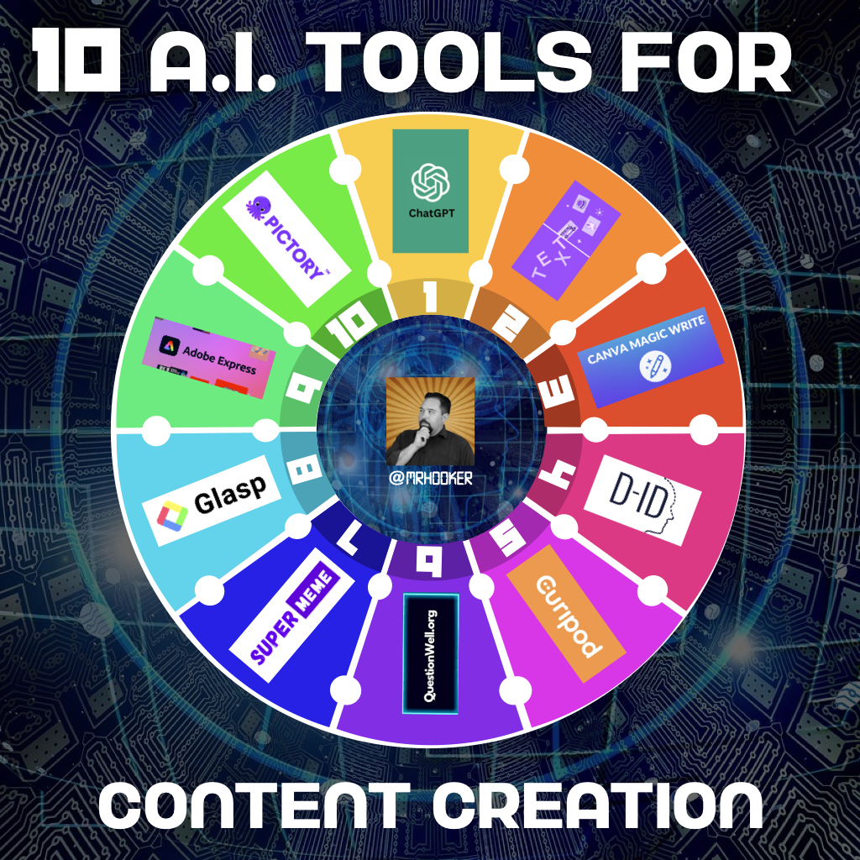

7.2 SEO Tools Powered by AI
AI SEO tools use machine learning to help improve your content so it becomes more popular
and visible. These tools continuously analyze and update your SEO strategies based on real-time data.The free AI SEO tools from Quattr look at search engine results pages (SERP) and create content that grabs users' attention.Their content is tailored to your specific needs,
ensuring it is both SEO-friendly and stays relevant.AI SEO tools are different from regular
SEO tools. Let’s explore what makes them unique.
  - Semrush One:
Semrush One is a major advancement in the field of online presence. It was introduced in October 2025 as an integrated tool that brings together the previously separate areas of
traditional SEO and artificial intelligence-based visibility tracking into a single platform
called Semrush. AI Visibility Toolkit lets you track brand mentions on AI search engines (ChatGPT, Perplexity, Google AI Mode)

  - ChatGPT
ChatGPT is one of the most popular AI tools around. You can use it to carry out entire conversations or put it to use as a content ideation tool. However, it also comes with many features that most users don’t know about. With the right prompts, it can compose audio tracks and generate logos.
Pricing
ChatGPT is free to use, but this basic version is very limited. ChatGPT Plus is an advanced version, with access costing $20 per month.
Pros
- Very easy to use
- One of the most versatile AI tools on the market
- Good choice for automation
Cons
- Free version is very limited
- Generated text can be unreliable
- Sometimes struggles with natural language understanding
  - Perplexity
Perplexity is a cutting-edge AI tool that transforms the way content creators perform web searches and research. It provides precise, context-aware answers by synthesizing information from multiple sources. Unlike traditional search engines, Perplexity presents summarized results alongside citations, enabling users to verify sources and dive deeper into topics. This feature is especially valuable for gathering data or supporting arguments in blogs, reports, or marketing campaigns.
Pricing
Perplexity offers a free plan with access to its core research capabilities. Premium options and advanced features may vary, depending on specific use cases or enterprise needs.
Pros
- Delivers quick, context-aware answers to research queries.
- Includes citations for transparency and deeper exploration.
- Streamlines the research process, saving time for content creators.
- Offers a user-friendly interface tailored for efficiency.
Cons
- Limited advanced functionality in the free plan.
- Not ideal for highly specific or niche queries that require deeper exploration beyond mainstream sources.
  - Surfer SEO:
- Surfer SEO remains the top choice for content optimization thanks to its advanced NLP
- engine and user-friendly interface. The realtime content score gives you clear,
actionable feedback as you write, and its integration with Google Docs and WordPress fits smoothly into your regular workflow. At $99 per month, Surfer
offers good value, though higher-tier plans may include features that could slow down your productivity. Additionally, AI writing tools, like Rankability’s AI Writer, come at an extra cost and add up over time. Despite this, Surfer’s proven ability to
improve search rankings, along with its simple and efficient design, makes it a dependable option for content marketing teams.
  - Frase
- Frase offers great value for its price by combining SERP research, AI writing help, and content optimization all in one platform for just $45 a month.
- It automatically creates content briefs, which saves a lot of time on research, and the AI writing tools help with writer's block and make content creation quicker. However, it doesn’t have the same level of keyword suggestion accuracy as more expensive tools like Surfer and Rankability. The free trial lasts five days with no risk involved.
While it doesn’t have the same SEO analysis features as specialized tools, Frase is a good fit for small businesses and individuals who need full content creation services without breaking the bank.
6) Jasper AI
Jasper AI is a powerful writing tool that helps users create high-quality content
quickly. No matter if you need to write a blog post, a Facebook update, a product
description, or any other kind of content, Jasper handles the difficult parts for you by using its GPT-3 technology.

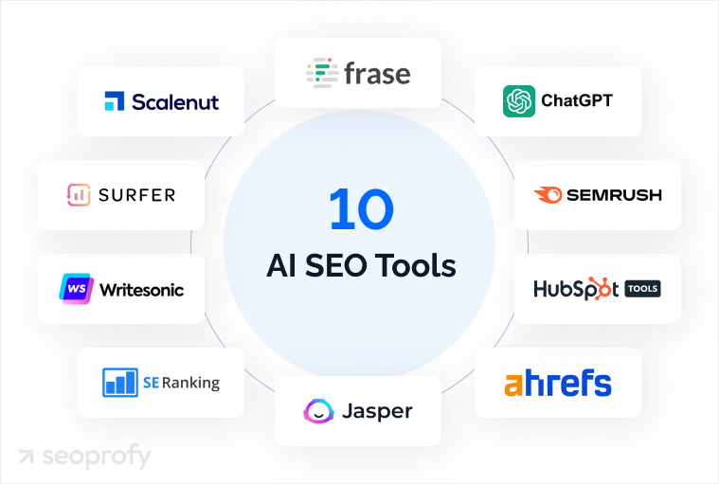

7.3 Analytics and Performance Tracking Tools

These tools track user engagement, keyword rankings, and future content performance.
  - Rankscale.ai:
Rankscale is a SaaS platform that provides AI-powered SEO, AI rank tracking, and
Generative Engine Optimization (GEO) tools. The platform evaluates how visible brands are in AI-generated responses by tracking mentions, citations,and sentiment across different large
language models and AI search engines, including GPT-5 if it's added to the engine list.
The Rankscale platform targets the GEO Tools segment.
  - Google Analytics 4 (GA4):
Built-in AI predictions for user behavior and tracking engagement across educational platforms. GA4 does not collect user data in the same way as UA. To collect user data, GA4 uses Google's Anonymous Identification technology and IP address, which means GA4 gathers less information from users compared to UA.
Additionally, GA4 has improved data security by setting a default data retention period of 14 months. This means the data will be automatically deleted after 14 months. UA, on the other hand, did not have a default data retention policy, and users had to set it themselves.
Lastly, unlike UA, where users couldn't opt out of tracking, GA4 allows users to disable
tracking through browser settings. Overall, GA4 seems more user-friendly and more
privacy-conscious. It collects less data and offers more privacy options to users.
  - Siteimprove:
Siteimprove.ai has created what is likely the most comprehensive DPO
software available today. This is thanks to their Siteimprove.ai Intelligence Platform, which offers valuable insights that help you and your team create
great content, drive traffic, track performance, and stay compliant.
In addition, Siteimprove.ai is happy to offer excellent customer support
and top-notch training programs, along with other helpful features.
  - MarketMuse:
MarketMuse is an AI tool that helps improve content strategies.It works by
learning aboutwhat experts say on particular topics, finding missing information in your content, and giving suggestions to make it better. This tool helps
with researching, planning, and making content better. By looking at your
existing content and checking what competitors are doing, MarketMuse
offers ideas to improve your content and find new topics that can help your
content rank higher in search engines.

  - SE Ranking: AI Overview Tracker for presence in Google’s AI-generated answers. The AI Search Toolkit from SE Ranking provides a Straightforward
solution to the changes in how users search. Rather than developing a single
tool to monitor AI usage, SE Ranking has built a complete set of tools that
address how AI functions within the search process.
7.4 Integration with Learning Management Systems (LMS)
Embedding tools into the LMS itself and turning in continuous delight for admins and teachers Brisk Teaching A Chrome extension that integrates directly into Google Docs and Classroom for instant AI feedback to students Edcafe AI Teachers can specify getting to know topics through QR codes and provide real-time dashboards with a purpose to sync to Canvas and Moodle .
Gradescope AI-Powered Grading Platform That Accelerates Evaluation in Better Ed
Chatbots/Virtual Tutors Embed tools like Chatfuel directly into your institution’s LMS for round-the-clock student assistance and quick enrollment solutions

Chapter 8: Implementation Strategy

8.1 Workflow Design for AI Integration
To be powerful, AI must be treated as a co-author and reading assistant, not a full replacement for human understanding that must comply with E-E-A-T (Experience, Expertise, Authority, and Trustworthiness).
Audit your workflows: Identify pain factors in content production, which includes lengthy approval processes for course descriptions or weblog posts.
Set Up Human-in-the-Loop (HITL): AI can provide sketches, drafts, and meta descriptions, but it’s much more important that subject matter experts (SMEs) evaluate content material for accuracy, especially in the training room where genuine earaches are not tolerated.
Content creation on an "AI-First" basis:
Strategic Information: Humans set the direction, targeting personalities and special attitudes.
AI Research & Outline: Use Frase or Jasper to examine the competition on SERPs and provide robust strategic keyword recommendations.
Drawing: Break the content into parts and allow AI to write the content segment-by-using-segment.
Human Augmentation: Add your personal experience, case studies, etc.
Content Repurposing: Take an unmarried long-form research paper or webinar and allow AI to generate a weblog set up, social media updates, and FAQ breakdown.
8.2 Content Lifecycle Management
AI can also play an indispensable function in the lifecycle management of content material from information to archive- ensuring software facts, educational content material, and blog posts stay sparkling and up-to-date.
Automated content audits - AI-powered crawlers to become aware of low-looking, outdated or thin content especially applicable while application requirements change
Automatically replace and refresh content material- Rewriting introductions to present articles, update statistics, or add FAQ's will mean "freshness" to search engines like google and yahoo.Topic Authority and Content Clustering - "Map out" Column content material, or "primary" sections of content material (i.e. "Online MBA Program") then use AI to augment and manage ancillary "subtopic" articles (i.e. "MBA Curriculum", "MBA Curriculum", "MBA Training Cost", career opportunities to stabilities".Restoration for accessibility- AI can be used to write recipes, create captions, or produce translations of instructional film images- to meet ADA compliance
8.3 SEO Strategy Implementation
The Position AI Plays in Search: Keyword Stuffing for Intent and Semantic Driven Search Engine Optimization.Semantic keyword research: Use keyword clustering and long-tail questions for your keyword research the use of AI features in equipment like SEMrush and Ahrefs (e.g. How to apply to X university vs college application).
On-page optimization: Maximize visibility for AI overviews with the help of optimizing your meta descriptions, title tags, headings (H1-H6), and content material format. Consider equipment that includes SurferSEO or Clearscope for help.
Entity-Based SEO & Schema: Structure hunting pleases resources for AI using incorporating JSON-LD schema markup for information about applications, events, and frequently requested questions.
Local SEO for agencies: Leverage AI to optimize your campuses Google Business Profiles (GBP) for accurate, consistent facts at some level in neighborhood directories.
8.4 Monitoring and Optimization
How content performs within AI and traditional search drives continuous improvement.AI Driven Performance Metrics: Pay attention to “Time from Brief to Published,” "Average Editing time," and "Organic Application Conversions."Monitor AI Overview Visibility: Check the frequency content is being pulled into AI Overviews (like Google's Search Generative Experience) via the available tools.
User Data: Review performance through Google Analytics 4 with attention paid to engagement rate and session duration to verify if the content is of value to the user.
Feedback loops: Collect feedback (from educators, and students) using Fireflies or Otter.ai to input it into AI for iterative content improvements.

Chapter 9: Case Studies and Applications
Within the EdTech sector, general AI professionals find themselves utilized in content creation and SEO. This blend of speed and accuracy is effective in content generation as the system automates many parts of SEO while still utilizing human review for quality control. These automated functions alleviate the pressure off educators by automating many time consuming parts of SEO and content creation and allowing them to focus more on learner engagement.
9.1 AI applications on EdTech platforms (2026)
AI finds its application in numerous EdTech platforms. A list of the most prevalent applications is below:
Personalized and adaptive content generation- These systems adapt quiz questions to the learner's competency and create unique learning pathways.
24/7 AI tutors with RAG- Schools utilize RAG to train their AI tutors to access specific curricula and answer student queries with a higher degree of accuracy.
Automated Educational SEO and marketing- Platforms focus on GEO, or "Generative Engine Optimization." These platforms are responsible for generating meta-descriptions, schema markup, and targeting long-tail keywords, all in a bid to improve a website's ranking.
Multilingual content localization- These platforms are increasingly being used to provide dubbing and translation of educational videos for learners worldwide.
9.2 Success Stories
Time Use in Special Education (IEP prep): The use of AI systems has cut down on practice time for IEPs.
Better Special Needs Outcomes: In a look at, it was found that the AI ​​equipment enabled detection, which a student detected slower through auditory cues and this enabled more comprehension.
ASU AI innovation mission: ASU started an AI company that led to the improvement of many projects, along with a chatbot targeted at nursing students.
Exponential Content Growth: An education company used AI to develop internet site content, and this causes an exponential growth in natural visitors.
9.3 Comparative Analysis
By 2026, the educational AI landscape is trending towards all-in-one and niche AI platforms.
Type of Tools Examples, and Focus Areas (2026)
All-in-one EdTech TeachBetter.ai, Canva Magic All-in-one tools to generate lessons, assessments and visual resources for students.
SEO & Content Surfer SEO, Frase.io Tools for long-form writing optimization and competitor and SERP feature analysis.
Research/Retrieval Perplexity, NotebookLM Tools for accurate, research-driven writing or internal documents synthesis.
Video/Audio Synthesia, Pictory AI AI avatar trainers and tools that auto generate video transcription and subtitles.
Chapter 10: Benefits and Impact Analysis
Using AI Generalists-like ChatGPT, or Claude-in education changes the nature of content creation and SEO management with a combination of automation and human-like capabilities. AI generalists serve as "connective tissue" in the span of tasks it undertakes, ranging from creating educational content, to Search Engine Optimization of marketing copy.
10.1 Improved Content Quality
Contextual Relevance: The AI identifies what is relevant to its audience, whether it be students, parents or professional. It uses top performing educational material and its analysis of user behaviour to do this.
Personalization: The AI generalists have the ability to change teaching material, blog post, study guide etc. To suit learners learning styles, abilities and pace in real time.
Depth and Accuracy: While requiring human intervention, the AI can help with structuring detailed and relevant educational material, for example, turning long text into condensed notes or creating detailed articles that are deeper than just the information itself.
10.2 Enhanced Search Visibility
Keyword Intelligence: The software uses a suite of equipment to grasp keywords and search for comprehensive on-demand styles to ensure educational content meets the person’s needs and searches.
Technical Search Engine Marketing Audit: AI performs and enables to pick out technical SEO issues and enhance normal internet site fitness and crawlability and speeds up the website.
Voice Search Optimization: The tool optimizes content for natural language searches, which may be an increasing number of essentials due to voice search and virtual assistant use.
10.3 Cost and Time Efficiency
Fast Content Generation- AI writes weblog articles, social media posts, and ad collateral in minutes instead of hours.
Automation of administration- Time-consuming responsibilities like grading, developing practice quizzes, and scheduling can be delegated to AI, allowing the workforce to focus on more critical areas.
Savings in operations- Educational institutions are likely to trade up to 30% of their operating costs by using the use of AI to transcribe content and perform administrative functions.
10.4 Student Engagement and Learning Outcomes
Engaging/interactive- AIs often make use of simulations and gamified content materials like duolingo as challenges to improve engagement and motivation levels.
Individualized assistance AI logs in for customized feedback and instant instruction through chatbots as well as person reading path, which works well to close the mastery gaps.
Improved memory-Individual reading is expanded while students get the customized and tasteful content material.
Chapter 11: Challenges and Risks
The usefulness of generalist AI for content time and SEO optimization in education produces profound blessings in terms of efficiency, while simultaneously giving rise to profound risks related to statistical assurance, content authenticity, and institutional morality.
11.1 Data Privacy and Security
The factual hunger of sufficiently good AI outputs is likely to be at odds with statistical minimization ideas, undoubtedly jeopardizing alongside point processing of private facts.
Handling Touching Information: Personal, instructional, and behavioral records make up the majority of records processed through AI systems in school settings and are, as a result, appealing targets for record breaches.
Salespeople & third birthday celebration risks: Use of 1/3-party AI structures can result in unintended record sharing, large information retention via 0.33 measures and use of information by scholars to practice their very own outside fashions.
Emerging cybersecurity threats: AI implementation will increase a school's "attack floor," making them more prone to advanced phishing attacks, malware infusion, and adversarial attacks along with set off injections.
11.2 Content Authenticity Issues
Due to the "black box" nature of AI models, it is particularly difficult to adjust the provenance and actual validity of its output, which is critical to the deliberation located on an academic Internet site. Hallucinations and misinformation. AI can also enrich fake or distorted facts with relentless reality, which can reduce search authority, however, important lie for college students.
Theft and lack of originality. AI works by taking existing content from the web and rendering it in a reformulated way, lacking proper originality of information or unique insight. This will devalue the data for search engines along with Google and is the basis for their Helpful Content updates.The loss of the human detail. Content created for educational purposes requires human empathy and vivid joy to be believed, something AI can neither have nor replicate. The lack of it could reduce the websites E-E-A-T fee.
11.3 Dependence on AI Systems
Excessive use of computer systems can additionally contribute to changes in the thinking of every instructor and novice.
Cognitive inertia and redundancy: A repeated pattern of depending on 'ready-made solutions' provided with the help of AI structures can also subsequently reduce a child's every mental attempt and exploration of ideas, leading to a decline in his cognitive abilities and his energy of unfettered wonder.
Reduction in instructor-student interaction: Use of AI based total structures for training in hybrid and on-line training modules may eventually reduce the scope of novice interaction with the instructor/instructor, and with it, skill guidance and comments may also be lost.
Disposal of talents of lecturers: Over dependence on AI based systems for composing written work and in studies ought to have an adverse effect on the writing skills and curiosity of the student and may even justify the deterioration of her ability to articulate her thoughts.
11.4 Ethical and Regulatory Concerns
The ever-evolving nature of AI brings challenges by means of growing at an extremely fast pace, faster than any kind of regulation can even begin to tackle it.
Algorithmic bias – AI structures can and have proven the tendency to absorb and exacerbate societal biases present in their school facts, and as a result give students discriminatory guidance or provide unfair automated grades.
Unclear Intellectual Property – Questions linger over who owns intellectual property created with the help of an AI system; the developer, organization, or stop user.
Regulatory compliance – institutions must comply via a large number of different worldwide laws, ranging from the GDPR (Europe) to the DPDP Act (India), all while ensuring that they do not violate students’ right to privacy or non-discrimination.

Chapter 12: Future Trends
By 2026, the penetration of AI generalists-AI vendors and large language models that can be proficient across quite a few commitments-into education will revolutionize content technology and seek engine visibility. In 2026, effective educational advertising and content materials methodology depends on a dual approach: AI offers the speed and scale while humans provide the integrity and trust (E-E-A-T).
12.1 Emerging AI Technologies in Education
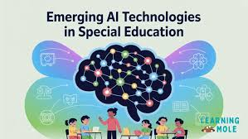
AI in education is moving from prototype chatbots to infrastructure level to deliver personalized experiences and operational performance.
AI-powered training and mentors: by 2026, AI mentors (like Kyron Learning) will offer personalized guidance 24/7 to find out a researcher to recognize gaps immediately and are discovered to growth courses final touch quote with 70% and reviews a 62% after ramp upwards pushing.
Agent AI for operations: Independent vendors cannot be exceptional in operational duties such as computerized responses of scholar enrollment questions, report generation, sending customized circle of related communications, and more.
Immersive AI classrooms: AI pushed AR/VR labs have become not uncommon for students in history, science, offering a comprehension retention of greater than seventy five%.
Wellbeing Analytics: AI systems are starting to use student registration factors of engagement, attendance, and temperament as a way to diagnose students who are randomized between 6-eight weeks in advance.
12.2 Future of SEO with AI
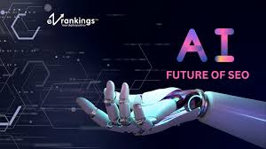
Artificial intelligence is changing how SEO works. SEO experts can now use AI to make
web content better, predict what search engines might focus on next, and give users more
tailored search results. For example, AI tools like Google's Search Generative Experience (SGE) can give quick answers without needing users to click through many links.Another big
change from AI in SEO is how it helps give users more personalized search results.AI can
understand what users are looking for and provide more relevant information.
This helps businesses meet what their customers want, and personalizing searches is a good way to do that.Also, AI-powered SEO tools are becoming more popular.These tools
help with tasks like finding the best keywords, improving content, and predicting future
search trends. With these tools, SEO experts can makeweb pages rank higher in search
results and work more efficiently.

Moving from Traditional SEO to AI-Driven SEO
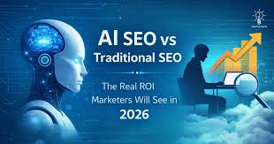
SEO has changed a lot over time. It used to be about matching keywords and building links, but now it uses machine learning algorithms to help with search engine optimization. Companies can now create content that is very specific and matches what their customers are
looking for, thanks to AI-powered tools.In the past, SEO mainly focusedon keywords and
link-building. But as the field evolved, new technologies and techniques were introduced,
making SEO easier and more effective. Today, AI-driven SEO strategies are widely used in the industry because they use advanced machine learning algorithms to improve optimization
efforts. These strategies help businesses better understand what users are searching for and create content that fits their audience's needs. Machine learning has had a big impact on how SEO is done.It allows for analyzing large amounts of data and finding useful patterns
and trends. The advantages of using machine learning in SEO are huge for businesses. It helps them stay competitive in the future by using smarter and more effective SEO strategies.
Search engine optimization has evolved in 2026 from stuffing key phrases into an editorial to GEO optimization - optimizing to be mentioned in AI responses, not just ranking in a top ten blue hyperlink end result. The Rise of Zero-Click Searches-Over ninety% of searches in a few AI methods no longer end even with a single click; now having an informed presence in the AI ​​overview is "status zero" to covet.
E-E-A-T-some foreign money-Engagements where the search engine sees that the author has first-hand experience, is a professional, and is authoritative has become a cornerstone of what Google considers valuable content, this comes from authoritative writer bios, proven degrees / credentials and reviews. Semantic and entity-based search-The search engine is moving from keyword primarily based on understanding principles. This method allows you to optimize not as independent sections of content material, but rather, content material groups of facts, (including qualifications, career accomplishments) rather than just character articles.
Multimodal search engine optimization-This means optimizing for voice search with conversational queries and along with a video (YouTube) of what you are speakme about, with based statistics so AI can easily check the item.
12.3 Predictive Content and Hyper-Personalization
Come 2026, personalized discussions not really using the user’s call; it refers to using AI to push responsive content that adapts to user desires and situations in real time.

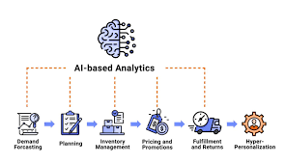

• Predictive Search Engine Optimization & Demand Forecasting: Student searches can be predicted using AI that analyzes behavioral characteristics and provides applicable content material to institutions.
• Hyper-customized to gain knowledge of pathways: Students will benefit from a pacing and training system tailored to their specific strengths and weaknesses, thereby increasing engagement with the help of 35%.
• Contextual engagement recognition: Marketing software now observes user behavior and regulates website content material or email transport to offer personalized suggestions primarily based on location, search records, and so on.
• Data privacy: As the landscape becomes more centralized ​round facts focused on, technologies by 2026 are firmly committed to respecting information privacy guidelines (e.g., FERPA, GDPR).
Chapter 13: Conclusion
From early 2026, in line with features of virtual advertising, AI generalists-specialists who combine various AI equipment, facts and human judgment-are the key to creating content and undertaking search engine optimization for educational topics. In 2026, AI is now not a content creation tool, however a comprehensive, agent-pushed workflow tool that drives search presence, especially given the real-world use of GEO and AI-pushed search overviews.
13.1 Summary of Findings
Search Engine Optimization is turning into GEO: The "old" keyword-focused optimization has morphed into Generative Engine Optimization (GEO). Now AI algorithms approximate emphasis on clear writing and quotable content material as alternative thankeyword junk mail.
AI Adoptions and Desire for Pace: Nearly half of all prospective college students record weekly use of an AI tool of their fact searches and three-quarters of entrepreneurs expect to increase use by the 2026 break.
Why "Human-in-the-loop" is important: Despite the momentum of introducing content materials, e.g. Overview of courses or posts and blog posts; unexamined content is a versatile offering to reality, not brand-safe, no longer an E-E-A-T piece of content material.
Which form of content material works right: We see AI search effects support direct, short answers in an FAQ format, but there is still a great need for a longer form content pieces to deliver Authority on an in-intensive situation.
Technical search engine marketing transformation: AI tools like Surfer search engine marketing and Rank Math allow entrepreneurs to streamline technical search engine marketing aspects like schema markups and page speed while also recognizing bottlenecks that prevent bot crawling.
13.2 Recommendations
Try a "Hybrid" content approach. Leverage AI writing assistants like Writesonic or Jasper.Ai for initial drafts and content thoughts. Then have overviews of human SMEs for factual accuracy, upload original insights, and test institutional tone.
Leverage quotable content structures. Build your academic website content material (software pages, college bios, subject results) around virtually structured, H2/H3 heading lists and FAQs with appropriate schema markup to make them highly citable with the help of AI overviews.
Invest in E-E-A-T and originality. Fight "AI slop" with real testimonials from researchers, character studies and real teacher profiles. Search engines in 2026 filter out content with little effort.
Test multiple AI search engines. Use an AI platform that provides visibility across ChatGPT, Gemini, and Perplexity to ensure your group’s story is delivered in an inclusive way on a Gemini-powered search panorama that continues to grow.
Investing in AI literacy schooling. Develop advertising teams in-house roughly acting as "AI editors" in Favor of content creators. Rather than specializing in human-driven keyword research, focus on sparking engineering and information evaluation skills.
13.3 Final Thoughts
In 2026, the opposition in advertising education is made up of people who see AI as a way to empower authority and agree. The "doing" part becomes automatic, and the "thinking" is still required of people. The future of search engine marketing will see a blend of AI that makes "doing" (content generation and technical audits) faster, while the human editor oversees that the content is useful, informed, and human-friendly.

Chapter 14: References
Dive into how AI is impacting the content creation process.
How to use generative AI for content creation in 2025.
Which changed the content creation landscape process for marketers.
The Power of AI: 6 Tools for Educational Content Description.
Top 10 AI tools for digital marketers in 2026.
Navigating Better Education SEO in 2026.
AI-powered seek is transforming higher education advertising and.
Increase Search Ranking in 2026 with the 10 AI Search Engine Marketing Equipment and Strategies.
Amabile, T. M., & Pratt, M. G. (2016). The dynamic components model of creativity and innovation in organizations: Making progress, making meaning. Research in Organizational Behavior, 36, 157–183. https://doi.org/10.1016/j.riob.2016.10.001
Ameen, N., Sharma, G. D., Tarba, S., Rao, A., & Chopra, R. (2022).
Toward advancing theory on creativity in marketing and artificial intelligence. Psychology & Marketing, 39(9), 1802–1825. https://doi.org/10.1002/mar.21699
Anantrasirichai, N., & Bull, D. (2022).
Artificial intelligence in the creative industries: A review. Artificial Intelligence Review, 55(1), 589–656. https://doi.org/10.1007/s10462-021-10039-7
Atkinson, D. P., & Barker, D. R. (1995).
The ritual of the creative process: ritual, creativity, ritual. In J. C. Kaufman & R. J. Sternberg (Eds.), The psychology of creativity (pp. 3–21). Cambridge University Press.
Davenport, T.H., & Ronanki, R.
Artificial intelligence for the real world
Harv.
Bus. Rev., 96 (1) (2018), pp. 108-116
Google Scholar
Rowell-Jones, A. and Howard, C.
2019 CIO Survey: CIOs Have Awoken to the Importance of AI
Retrieved from
(2019)
https://www.gartner.com/en/documents/3897266/2019-cio-survey-cios-have-awoken-to-the-importance-of-ai
Google Scholar
Fountaine, T., McCarthy, B. and Saleh, T.
Building the AI-powered organization
Harv.
Bus. Rev. (2019), pp. 63-73
Google Scholar
Ransbotham, S., Gerbert, P., Reeves, M., Kiron, D. and Spira, M.
Artificial Intelligence in Business Gets Real
MIT Sloan Management Review (2018)
Google Scholar
Ransbotham, S., Khodabandeh, S., Fehling, R., LaFountain, B. and Kiron, D.
Winning with AI
MIT Sloan Management Review (2019), p. 61180
Google Scholar
Brynjolfsson, E., Rock, D. and Syverson, C.
Artificial intelligence and the modern productivity paradox: a clash of expectations and statistics
The Economics of Artificial Intelligence: an Agenda, University of Chicago Press (2018)
Google Scholar
Bharadwaj, A.
A resource-based perspective on information technology capability and firm performance: an empirical investigation
Mis Q., 24 (1) (2000), pp. 169-196
View at publisherCrossrefGoogle Scholar
Gupta, M. and George, J.F.
Toward the development of a big data analytics capability

Chapter 15: Appendices
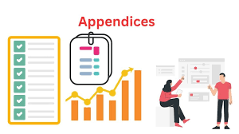
Appendix A: AI Powered Tool Stack for Educational Content & Search Engine Optimization.
The categories indexed are the comprehensive types of software rented in automation for the introduction of instructional materials, and for search ranking.
Content generation and drafting: along with Jasper AI (Jasper.Ai) to write the first drafts of blog posts, and lead descriptions. Typeface (Typeface.Ai) can ensure the content is knowledgeable with specific understanding of a chosen brand and research conducted on the estate.
Search engine optimization and target audience insights: together with Surfer search engine marketing (SurferSEO.Com) and Semrush Copilot (Semrush.Com) which offer upkeep advice on keyword difficulty and current authority, as well as technical site problems.
Multimedia and accessible reading: Synthesia (Synthesia.Io) allows the scripts to be produced for narrative e-industry knowledge about films with AI avatars and Lumen5 (Lumen5.Com) allows current blog content to be turned into video content and for this reason increase the e-culture on social media.

Image and presentation: Gamma AI (Gamma.App) automatically designs the layout of teaching materials and interactive presentations and Canva Magic Studio (Canva.Com) helps to create graphics such as infographics, and thumbnails.
Appendix B: Academic Search Engine Optimization Performance Metrics
By monitoring the targeted metrics, we are able to incrementally fulfill our AI in creating organic enrollment of researchers.
Metric Language AI Software Conversion Rate This calculates how many student inquiries trigger path enrollment or registration. The AI ​​can then decide in which particularly personalized CTAs to display.
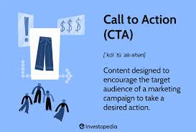
Organic traffic This measures how many visitors to a scholar site we get through search. AI makes it possible to identify keywords that students use with a reason to sign up.
Bounce Rate This measures how relevant visitors to a search engine page are to the touchdown page. AI will optimize landing pages for specific search intents.

Featured Snippet Rank This represents visibility in 'role 0', which is ideal for answering real queries. AI can help prepare solutions and become aware of regularly requested questions from students.

Appendix C: Strategic Implementation of Tagging List
This checklist should help you flow from a manual-driven content approach to an AI-pushed teaching approach.
Create brand voice guidelines: Know the AI ​​fashion for your exact brand voice, authoritative sources, to ensure consistency across the board.

Set up content repurposing workflow: Enable automation to create social snippets, collections of blogs, or email newsletters from your extensive reviews or webinars.
Implement AEO/GEO optimization: Structure your website FAQs or neighborhood landing pages to be picked up with the help of voice search or map results.
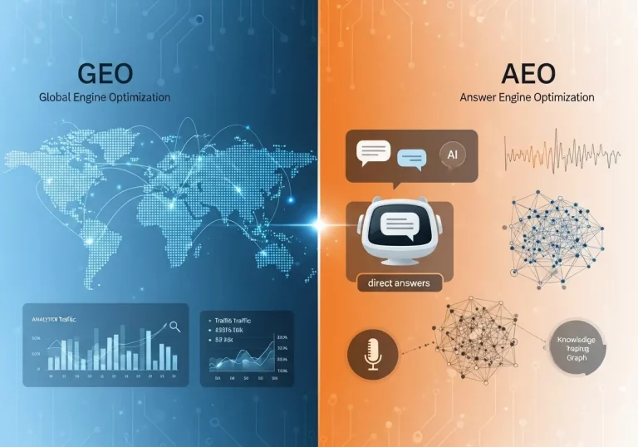
Set up human verification workflows: Ensure mandatory human reviews of all AI content to verify technical accuracy and ethical statistical stewardship.
Automate Technical Search Engine Marketing Tests: Set up computerized schedules to run AEO tests, identify broken links, drop points, or boost web page speed.

Appendix D: Readings and Resources to Expand Your Understanding
The following sources will offer further guidance on using AI for content creation and search engine optimization to its full potential:
A practical guide: "The future of content material access: embracing AI for success" can be found on Amazon India.
Workflows: The "AI-DRIVEN CONTENT CREATOR" has intelligent recommendations for automating content material generation and scaling your efforts-also to be had on Amazon India.
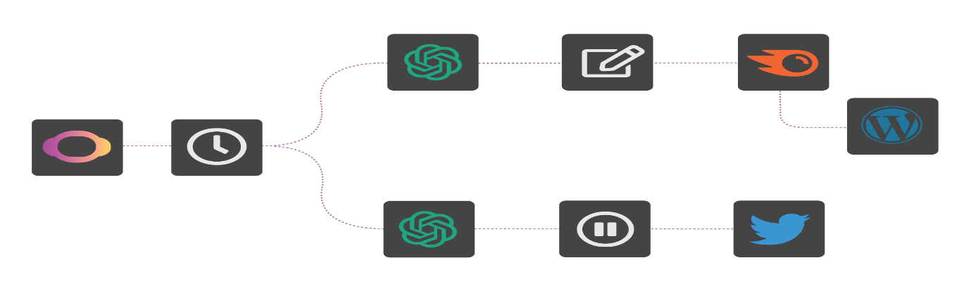
Industry Blogs: Caylor Solutions’ reviewers and experts are a key supply of facts specifically designed for advertising in better school performance.


